**B.SC FINAL YEAR PROJECT REPORT**

ST. XAVIER'S COLLEGE [AUTONOMOUS], KOLKATA

**Department of Computer Science**

##### “FACIAL RECOGNITION BASED ATTENDANCE SYSTEM”

**PAPER CODE: CS36581**

**by**

**KINGSHUK MUKHERJEE**

**Roll No: 514**

**Registration No: A01-1112-0761-16**

**Under Guidance of**

**PROF. SONALI SEN**

**Submitted on: April 4, 2019**

# CERTIFICATE OF ORIGINALITY

This is to certify that the project report entitled ________________________________________ submitted to **St. Xavier's College** [Autonomous], Kolkata in partial fulfilment of the requirement for the award of the degree of **B.Sc. Computer Science (Honours),** is an authentic and original work carried out by Mr. / Ms._____________________________________

with roll number _______________________under my guidance.

This project is a genuine work done by the student and has not been submitted to any other College / University / Institute for any purpose.

………………………. ...…………………….

Signature of the Student: Signature of the Guide

Date: ……………….. Date: …………………

Name and Address Name, Designation

of the student and Address of the

Guide:

……………………….. ………………………..

……………………….. ………………………..

……………………….. ………………………..

……………………….. ………………………..

Roll No…………

# ROLES AND RESPONSIBILITIES FORM

**Name of the Project**………………………………………………………**Date:**………………

|  |  |  |
| --- | --- | --- |
| **Name of the Team Member** | **\*Role** | **Tasks and Responsibilities** |
| 1. |  |  |
| 2. |  |  |
| 3. |  |  |

Name and Signature of the **Project Team members:**

#### 1……………………………….. Signature.…………………………

#### 2……………………………….. …………………………………….

#### 3……………………………….. ……………………………………

#### Signature of the Guide :……………………… Date: ………......

# ABSTRACT

In schools and universities, taking of attendance is an important part of the teaching learning process. It is a viable measure of student performance and engagement with the university. In manual classroom attendance, the professor calls student names sequentially. This method might become time-consuming and error-prone if the class size is large. Hence there is a need to automate the process. The aim of this project has been to develop a complete attendance system using face detection and face recognition algorithms that fully automates the attendance process. The face of the student can be identified without any sort of action on the part of the student, making it a more suitable and time-saving method.

The objectives of the project have been to implement a solution to the manual classroom attendance problem by using facial detection and facial recognition algorithms, eliminating the practice of giving proxy attendance, and maintaining the record in an excel spreadsheet that is updated automatically. This sheet is sent through email to the administrators who can then publish it on the college website or do any other such suitable task.

It uses the Local Binary Pattern Histogram (LBPH) method to compare the training images and test images, and marking the students present or absent based on the results. Good results have been obtained on testing the program on multiple subjects.

# ACKNOWLEDGEMENT

It is our pleasure to express our heartfelt thanks to Prof. Sonali Sen of the Department of Computer Science, St. Xavier’s College, who was our project supervisor and provided us with valuable suggestions to make this project a success.

We would also like to thank Prof. Shalabh Agarwal, Head of The Department of Computer Science, St. Xavier’s College, for his guidance in every aspect of the development of the project work.

Lastly, we take this opportunity to thank all the individuals who directly and indirectly gave their valuable assistance to us.

# TABLE OF CONTENTS

**ABSTRACT**..................................................................................................................................4

**ACKNOWLEDGEMENT**...........................................................................................................5

**TABLE OF CONTENTS**.............................................................................................................6

**TABLE OF FIGURES**.................................................................................................................8

**CHAPTER 1: INTRODUCTION**

1.1 Background...................................................................................................................9

1.2 Objectives....................................................................................................................11

1.3 Need for Proposed System..........................................................................................12

1.4 Applicability................................................................................................................12

1.5 Organization of Report................................................................................................13

**CHAPTER 2: FACIAL RECOGNITION**

2.1 Face Detection Algorithm............................................................................................14

2.2 Face Recognition Algorithm........................................................................................17

**CHAPTER 3: SYSTEM DESIGN**

3.1 Problem Definition.......................................................................................................22

3.2 Concise Specification of Requirements.......................................................................23

3.3 Conceptual Models......................................................................................................24

3.4 Basic Modules..............................................................................................................26

3.5 Data Design..................................................................................................................27

3.6 Procedural Design........................................................................................................28

3.7 Dataset Capture Algorithm..........................................................................................30

3.8 Training Dataset Algorithm.........................................................................................31

3.9 Recognizer Algorithm..................................................................................................32

3.10 User Interface Design................................................................................................33

**CHAPTER 4: IMPLEMENTATION**

4.1 Implementation Approaches…………………………………………………………40

4.2 Coding Details……………………………………………………………………….41

**CHAPTER 5: RESULTS AND DISCUSSION**

5.1 Outputs……………………………………………………………………………….79

5.2 Discussion…………………………………………………………………………....93

**CHAPTER 6: CONCLUSIONS**

6.1 Limitations of the System……………………………………………………………95

6.2 Future Scope…………………………………………………………………………96

**REFERENCES**………………………………………………………………………………97

# TABLE OF FIGURES

1. Figure-1: Haar-like features……………………………………………………………...15
2. Figure-2: Haar features superimposed on a facial image………………………………...16
3. Figure-3: LBPH algorithm – basic procedure……………………………………………18
4. Figure-4: Circular LBP…………………………………………………………………..19
5. Figure-5: Generating histograms on the basis of LBP algorithm………………………..20
6. Figure-6: Schematic diagram of system, with real world entities……………………….24
7. Figure-7: Schematic diagram of system, with coding modules……………………….....25
8. Figure-8: Level-1 DFD of system………………………………………………………..27
9. Figure-9: Schematic diagram of system with script names and control flow……………29
10. Figure-10: Dataset capture module flowchart……………………………………………30
11. Figure-11: Training dataset module flowchart…………………………………………..31
12. Figure-12: Recognizer module flowchart………………………………………………..32

CHAPTER 1:

INTRODUCTION

# 1.1 Background

In schools and universities, student attendance is a vital part of the administration process. The common or classical method of taking attendance in universities is that, the professor calls the names or roll numbers of the students, to which they verbally respond and the attendance is noted. This method works effectively only when the class size is significantly small.

For very large classes with the number of students exceeding 50 or more, this classical method turns out to be ineffective and tedious, taking up valuable time from the total duration of the lecture. This process could be automated using different techniques like biometrics and face recognition.

Biometric based technologies include identification based on physiological characteristics (such as face, fingerprints, finger geometry, hand geometry, hand veins, palm, iris, retina, ear and voice) and behavioural traits (such as gait, signature and keystroke dynamics).

Face recognition appears to offer several advantages over other biometric methods, a few of which are outlined here: Almost all these technologies require some voluntary action by the user, i.e., the user needs to place his hand on a hand-rest for fingerprinting or hand geometry detection and has to stand in a fixed position in front of a camera for iris or retina identification.

However, face recognition can be done passively without any explicit action or participation on the part of the user since face images can be acquired from a distance by a camera. This is particularly beneficial for security and surveillance purposes. Furthermore, data acquisition in general is fraught with problems for other biometrics: techniques that rely on hands and fingers can be rendered useless if the epidermis tissue is damaged in some way (i.e., bruised or cracked).

Face detection is used to locate the position of face region and face recognition is used for marking the understudy’s attendance. The database of all the students in the class is stored and when the face of the individual student matches with one of the faces stored in the database then the attendance is recorded.

# **1.2** Objectives

The objectives of our project are as follows.

* To develop a prototype that implements face detection and face recognition algorithms for students in a classroom to facilitate attendance registering by the use of a webcam.
* To implement measures that will detect spoofing, i.e., attempting to recognize an image of a student instead of the real person.
* To implement a friendly graphical user interface that will help in the process of registering the attendance.
* To implement a robust database that will be updated automatically.
* To send the database via email to administrators so that they can publish the attendance report on the college website for access of students.

# 1.3 Need for Proposed System

It has been shown that there is a positive correlation between attendance and examination performance[1]. It is clear that attendance is an extremely vital measure of student evaluation. But, it is observed in practice that the method of taking attendance is fraught with errors and shortcomings. Common classroom attendance is taken on paper, whereby the professor calls each student by name and waits for their auditory response before marking them present or absent manually on the attendance register. In a class with a large student population, it is seen that this process consumes a significant portion of the time allotted for the class, thus affecting the duration of the lecture negatively. The student might not be responsive enough even if they are present, and therefore unfairly lose their attendance. Also, there is a practice of giving proxy attendance, i.e., a student responds for the attendance of a different student. Thus, there are a number of problems associated with manual classroom attendance.

Hence there is a requirement to automate this process. A possible solution to this problem that might make the attendance process more secure and free of human errors is the use of facial detection and recognition algorithms to record attendance in which no active action by the student is required.

# 1.4 Applicability

Although the proposed system has been implemented mainly keeping the requirements of schools and universities in mind, it can be used (with some modifications) in any scenario where the systematic acceptance, verification, and recording of attendance is needed. The comparatively generic nature of the basic project purpose will help not only in universities but also in offices and corporations where rigorous employee attendance records are to be maintained.

# 1.5 Organization of Report

In chapter 2, the primary methods used for face detection and facial recognition have been covered in detail. In chapter 3, the complete system has been described along with description of each individual module and accompanying algorithms. Chapter 4 deals with the actual implementation, with the complete source code of the system. The results obtained and directions for use of the system have been provided in chapter 5. The final chapter concludes the project along with some discussions about the limitations of the system its future scope.

CHAPTER 2:

FACIAL RECOGNITION

# 2.1 Face Detection Algorithm

Haar-like features are digital image features used in object recognition. They owe their name to their intuitive similarity with Haar wavelets and were used in the first real-time face detector.[2]

Historically, working with only image intensities (i.e., the RGB pixel values at each and every pixel of image) made the task of feature calculation computationally expensive. A publication by Papageorgiou et al.[3] discussed working with an alternate feature set based on Haar wavelets instead of the usual image intensities. Viola and Jones[2] adapted the idea of using Haar wavelets and developed the so-called Haar-like features. A Haar-like feature considers adjacent rectangular regions at a specific location in a detection window, sums up the pixel intensities in each region and calculates the difference between these sums. This difference is then used to categorize subsections of an image. For example, let us say we have an image database with human faces. It is a common observation that among all faces the region of the eyes is darker than the region of the cheeks. Therefore a common Haar feature for face detection is a set of two adjacent rectangles that lie above the eye and the cheek region. The position of these rectangles is defined relative to a detection window that acts like a bounding box to the target object (the face in this case).

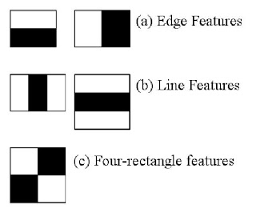

Figure-1: Haar-like features.

Initially, the algorithm needs a lot of positive images (images of faces) and negative images (images without faces) to train the classifier. Then we need to extract features from it. For this, Haar features shown in the below image are used. They are just like our convolutional kernel. Each feature is a single value obtained by subtracting sum of pixels under the white rectangle from sum of pixels under the black rectangle.

Now, all possible sizes and locations of each kernel are used to calculate lots of features. (Just imagine how much computation it needs? Even a 24x24 window results over 160000 features). For each feature calculation, we need to find the sum of the pixels under white and black rectangles. To solve this, they introduced the integral image. However large your image, it reduces the calculations for a given pixel to an operation involving just four pixels.

But among all these features we calculated, most of them are irrelevant. For example, consider the image below. The top row shows two good features. The first feature selected seems to focus on the property that the region of the eyes is often darker than the region of the nose and cheeks. The second feature selected relies on the property that the eyes are darker than the bridge of the nose. But the same windows applied to cheeks or any other place is irrelevant. So how do we select the best features out of 160000+ features?

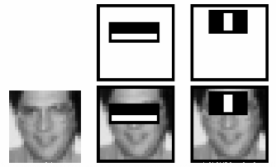

Figure-2: Haar features superimposed on a facial image.

For this, we apply each and every feature on all the training images. For each feature, it finds the best threshold which will classify the faces to positive and negative. Obviously, there will be errors or misclassifications. We select the features with minimum error rate, which means they are the features that most accurately classify the face and non-face images. (The process is not as simple as this. Each image is given an equal weight in the beginning. After each classification, weights of misclassified images are increased. Then the same process is done. New error rates are calculated. Also new weights. The process is continued until the required accuracy or error rate is achieved or the required number of features are found).

The final classifier is a weighted sum of these weak classifiers. It is called weak because it alone can't classify the image, but together with others forms a strong classifier. The paper says even 200 features provide detection with 95% accuracy. Their final setup had around 6000 features. (Imagine a reduction from 160000+ features to 6000 features. That is a big gain).

So this is a simple intuitive explanation of how Viola-Jones face detection works.

# 2.2 Face Recognition Algorithm

Local Binary Pattern (LBP) is a simple yet very efficient texture operator which labels the pixels of an image by thresholding the neighborhood of each pixel and considers the result as a binary number.[4]

It was first described in 1994 (LBP) and has since been found to be a powerful feature for texture classification. It has further been determined that when LBP is combined with histograms of oriented gradients (HOG) descriptor, it improves the detection performance considerably on some datasets.

Using the LBP combined with histograms we can represent the face images with a simple data vector.

As LBP is a visual descriptor it can also be used for face recognition tasks, as can be seen in the following step-by-step explanation.

Steps of the algorithm:

Parameters: the LBPH uses 4 parameters:

1. Radius: the radius is used to build the circular local binary pattern and represents the radius around the central pixel. It is usually set to 1.
2. Neighbors: the number of sample points to build the circular local binary pattern. The more sample points included, the higher the computational cost. It is usually set to 8.
3. Grid X: the number of cells in the horizontal direction. The more cells, the finer the grid, the higher the dimensionality of the resulting feature vector. It is usually set to 8.
4. Grid Y: the number of cells in the vertical direction. The more cells, the finer the grid, the higher the dimensionality of the resulting feature vector. It is usually set to 8.

Training the Algorithm: First, we need to train the algorithm. To do so, we need to use a dataset with the facial images of the people we want to recognize. We need to also set an ID (it may be a number or the name of the person) for each image, so the algorithm will use this information to recognize an input image and give you an output. Images of the same person must have the same ID. With the training set already constructed, let’s see the LBPH computational steps.

Applying the LBP operation: The first computational step of the LBPH is to create an intermediate image that describes the original image in a better way, by highlighting the facial characteristics. To do so, the algorithm uses a concept of a sliding window, based on the parameters radius and neighbors.

The image below shows this procedure:

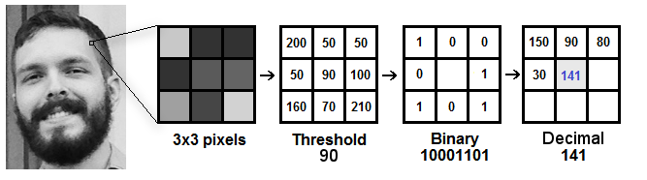

Figure-3: LBPH algorithm – basic procedure.

Based on the image above, let’s break it into several small steps so we can understand it easily:

Suppose we have a facial image in grayscale.

We can get part of this image as a window of 3x3 pixels.

It can also be represented as a 3x3 matrix containing the intensity of each pixel (0~255).

Then, we need to take the central value of the matrix to be used as the threshold.

This value will be used to define the new values from the 8 neighbors.

For each neighbor of the central value (threshold), we set a new binary value. We set 1 for values equal or higher than the threshold and 0 for values lower than the threshold.

Now, the matrix will contain only binary values (ignoring the central value). We need to concatenate each binary value from each position from the matrix line by line into a new binary value (e.g. 10001101). Note: some authors use other approaches to concatenate the binary values (e.g. clockwise direction), but the final result will be the same.

Then, we convert this binary value to a decimal value and set it to the central value of the matrix, which is actually a pixel from the original image.

At the end of this procedure (LBP procedure), we have a new image which represents better the characteristics of the original image.

Note: The LBP procedure was expanded to use a different number of radius and neighbors, it is called Circular LBP.

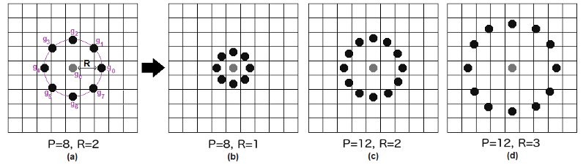

Figure-4: Circular LBP.

It can be done by using bilinear interpolation. If some data point is between the pixels, it uses the values from the 4 nearest pixels (2x2) to estimate the value of the new data point.

Extracting the Histograms: Now, using the image generated in the last step, we can use the Grid X and Grid Y parameters to divide the image into multiple grids, as can be seen in the following image:

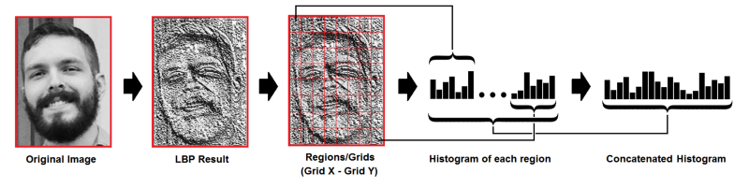

Figure-5: Generating histograms on the basis of LBP Algorithm

In the LBP approach for texture classification, the occurrences of the LBP codes in an image are collected into a histogram. The classification is then performed by computing simple histogram similarities.[5]

Based on the image above, we can extract the histogram of each region as follows:

As we have an image in grayscale, each histogram (from each grid) will contain only 256 positions (0~255) representing the occurrences of each pixel intensity.

Then, we need to concatenate each histogram to create a new and bigger histogram. Supposing we have 8x8 grids, we will have 8x8x256=16.384 positions in the final histogram. The final histogram represents the characteristics of the image original image.

Performing the face recognition: In this step, the algorithm is already trained. Each histogram created is used to represent each image from the training dataset. So, given an input image, we perform the steps again for this new image and creates a histogram which represents the image.

So to find the image that matches the input image we just need to compare two histograms and return the image with the closest histogram.

We can use various approaches to compare the histograms (calculate the distance between two histograms), for example: euclidean distance, chi-square, absolute value, etc. In this example, we can use the Euclidean distance (which is quite known) based on the following formula:

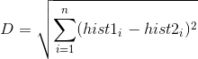

So the algorithm output is the ID from the image with the closest histogram. The algorithm should also return the calculated distance, which can be used as a ‘confidence’ measurement. Lower confidences are better because it means the distance between the two histograms is closer.

We can then use a threshold and the ‘confidence’ to automatically estimate if the algorithm has correctly recognized the image. We can assume that the algorithm has successfully recognized if the confidence is lower than the threshold defined.

In out project, the confidence threshold has been set to 50, because it was observed that we were getting satisfactory results with that threshold.

The LBPH algorithm is one of the basic algorithms used for facial recognition, and is pre-defined in the OpenCV Library.

CHAPTER 3:

SYSTEM DESIGN

# 3.1 Problem Definition

Students’ attendance is an important part of any university administration and also a measure of student performance. Manual classroom attendance in which verbal response is required is time-consuming and error-prone (i.e., a student might miss their attendance if they cannot respond on time). Hence there is a requirement to automate this process. A possible solution to this problem that might make the attendance process more secure and free of human errors is the use of facial detection and recognition algorithms to record attendance in which no active action by the student is required.

The basic problem can be divided into the following sub-problems – (a) creation of the database system containing the faculty and administrator functions; (b) implementation of facial recognition algorithm; (c) recording the attendance results in an excel spreadsheet that will be displayed; (d) implementing anti-spoofing measures.

# 3.2 Concise Specification of Requirements

1. The system should provide separate control to faculty and administrator. Administrator is responsible for creating and training the data set of students, and faculty is responsible for ‘taking’ the attendance, i.e, running the specific part of the program in the class that recognizes the students’ faces.
2. The system should maintain a database of the faculty along with username/email and password with facilities to add or create new faculty members.
3. The system should provide comprehensive and friendly user interfaces separately for faculty and administrator, with their functions clearly distinguished.
4. The system should be able to create a dataset of multiple student faces with their corresponding roll numbers or IDs.
5. The system should be able to train the model on the created data set.
6. The system should return an excel spreadsheet at the end of the process of taking attendance, with a record of the student names and roll numbers and information about their presence.
7. The system should be able to send the excel spreadsheet via email to the administrators so that they can do the needful with the sheet (i.e, publish the report on website for easy access of students, etc).
8. The system should be able to detect if instead of a real face, an image of the face is provided to it for recognition. It should be able to detect this phenomenon (called ‘spoofing’) and thereby block the attendance.

# 3.3 Conceptual Models

A basic model of the system is shown below, with entities modeled after real-life entities who will actually use the software.

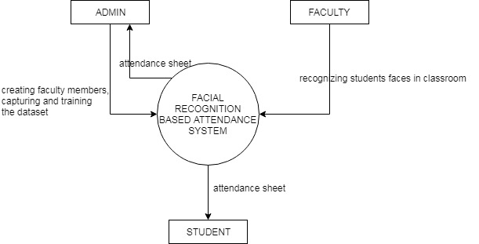

Figure-6: Schematic diagram of system, with real world entities.

The administrator has the functions of signing up faculty members, creating the dataset of students faces and training them. The faculty will take the attendance and an excel spreadsheet will be generated, which can be then sent via email to administrator.

The student can access the attendance sheet by providing his/her ID.

Another model is shown, which shows the actual entities in the program.

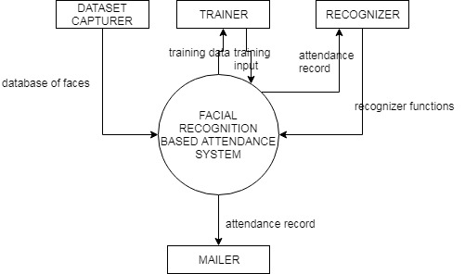

Figure-7: Schematic diagram of system, with coding modules.

The administrator has access to the trainer and dataset capturer modules. The faculty has access to the recognizer and mailer modules. These modules don’t represent real world entities like administrator and faculty – they are basic representations of the entities and modules developed for use within the code.

# 3.4 Basic Modules

The project has been divided into several modules that interact with each other. A brief description of each of these modules is given below.

* UI – The User Interface has been developed in conjunction with the rest of the project. The user interface handles all the aspects of the project, mainly the administrator and faculty modules and the ways in which they interact with each other and the rest of the project.
* Admin – The administrator module has the responsibility of creating accounts of new faculty members, and creating the dataset of the students’ faces. In a typical university setting, the administrator will use the program for the newly enrolled students and create dataset containing IDs and faces.
* Faculty – The faculty represents the different professors who have to take the attendance daily in class. Faculty module provides options for logging in of faculty members, and using the program to recognize the faces and take attendance. Finally, it generates an automatic excel spreadsheet with the records of the attendance of the day.
* Dataset Capturer – Handles the creation of the student’s dataset.
* Training Dataset – Trains the images processed and captured by the dataset capturer using facial recognition algorithm.
* Recognizer – Combines the functionalities of Dataset Capturer module and Training Dataset module, to recognize the student’s faces. This module also generates the excel spreadsheet.
* Mailing module – The faculty has access to a mailer, that will mail the generated excel spreadsheet to each administrator. The module has been created specifically for gmail.com.

# 3.5 Data Design

The project contains a single database in which the usernames and passwords of the administrator and the faculty are stored. A level-1 Data Flow Diagram is given below for clarity.

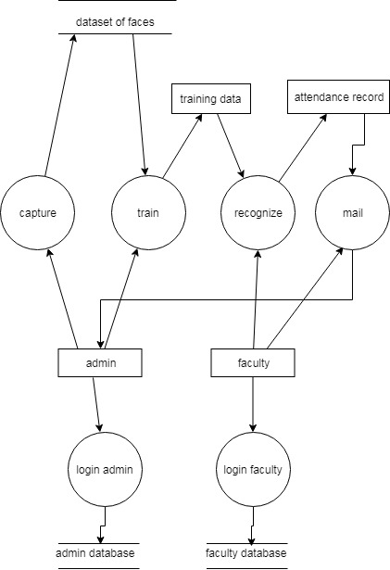

Figure-8. Level-1 DFD of System

# 3.6 Procedural Design

A typical run of the system proceeds as follows, with the required filenames (or modules) accessed in each step.

1. The project begins at page1.py, where option for faculty or admin is provided.
2. On clicking the option for faculty, the program goes to page2.py, which provides option for login of faculty.
3. On login, the program goes to loginfaculty.py, where the option to login to the system is provided along with space for username and password. This page interacts with the database backend created with SQLite.
4. If login is successful, the program goes to firstpage.py. This program displays options for recognizing the student’s faces and generating the attendance sheet, and also sending mail to the admin.
5. Mail sending is handled by the module named m.py.
6. The recognizing of students is handled by the script recognizer.py, which also generates the attendance sheet as an excel spreadsheet.
7. If, on the other hand, one clicks the option for admin, the program goes to loginadmin.py, which shows admin login/signup page. Here, new admin members can be added or existing user accounts can be logged in to.
8. The loginadmin.py script handles the login and sign up options. This page interacts with the database backend created with SQLite.
9. In this page, the provision of adding new admin members has been given. There are two separate databases for administrator and faculty.
10. On successful admin login, the program goes to firstpage1.py. This page has the option of capturing the students faces, training the captured dataset and displaying the backend database created in SQLite. This page handles the creation of new accounts for faculty members, and to achieve this it directs the control to the page fsignup.py
11. The scripts dataset_capture.py and training_dataset.py handle the capturing and training of data images, respectively.

This has been represented by a schematic diagram, as given below.

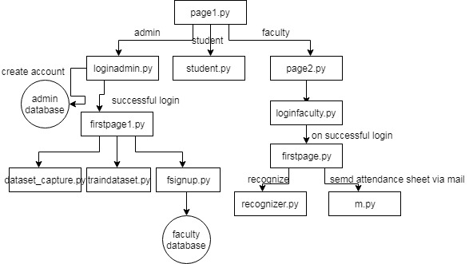

Figure-9: Schematic Diagram of System With Script Names And Control flow.

The main algorithms that have been used are the recognizer, dataset capture, and the training dataset. These are illustrated below.

# 3.7 Dataset Capture Algorithm

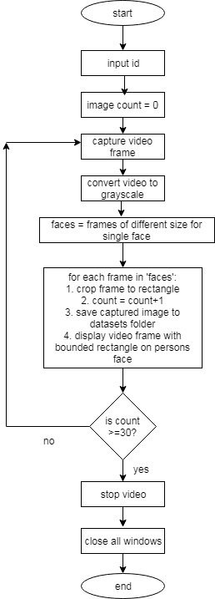

Figure-10: Dataset capture module flowchart.

# 3.8 Training Dataset Algorithm

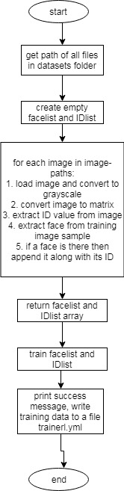

Figure-11: Training Dataset module flowchart.

# 3.9 Recognizer Algorithm

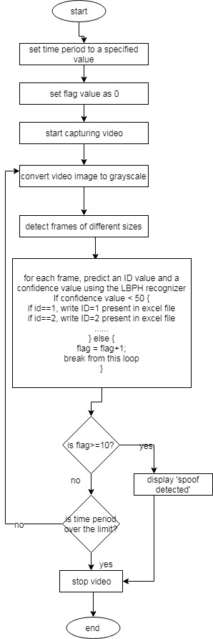

Figure 12: Recognizer module flowchart.

# 3.10 User Interface Design

The user interface has been designed to be as friendly and concise as possible. What follows is a basic structure of the user interface, with screenshots and explanations wherever required.

The user interface has been designed keeping in mind ease of use and clarity. It follows a basic point and click approach that gives a comprehensive access to all the modules and functions described in the previous sections. What follows is a basic walk-through that will help in understanding the exact functionalities provide by the program.

The program opens at the following screen:

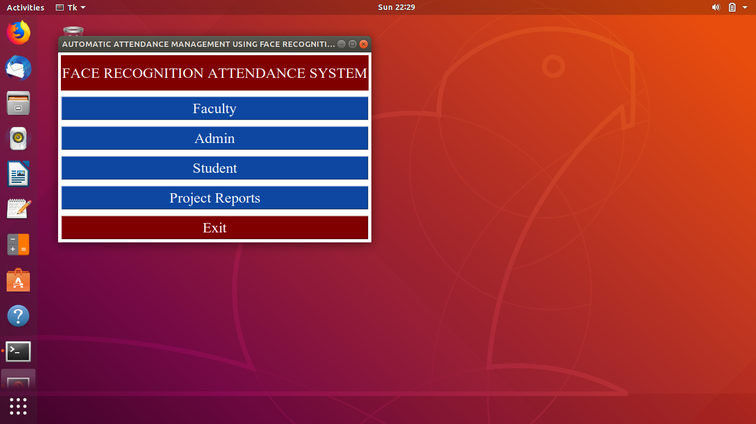

When run for the first time, no administrators or faculty members exist. The admin and faculty members are added by clicking the ‘admin’ button, which provides the following screen:

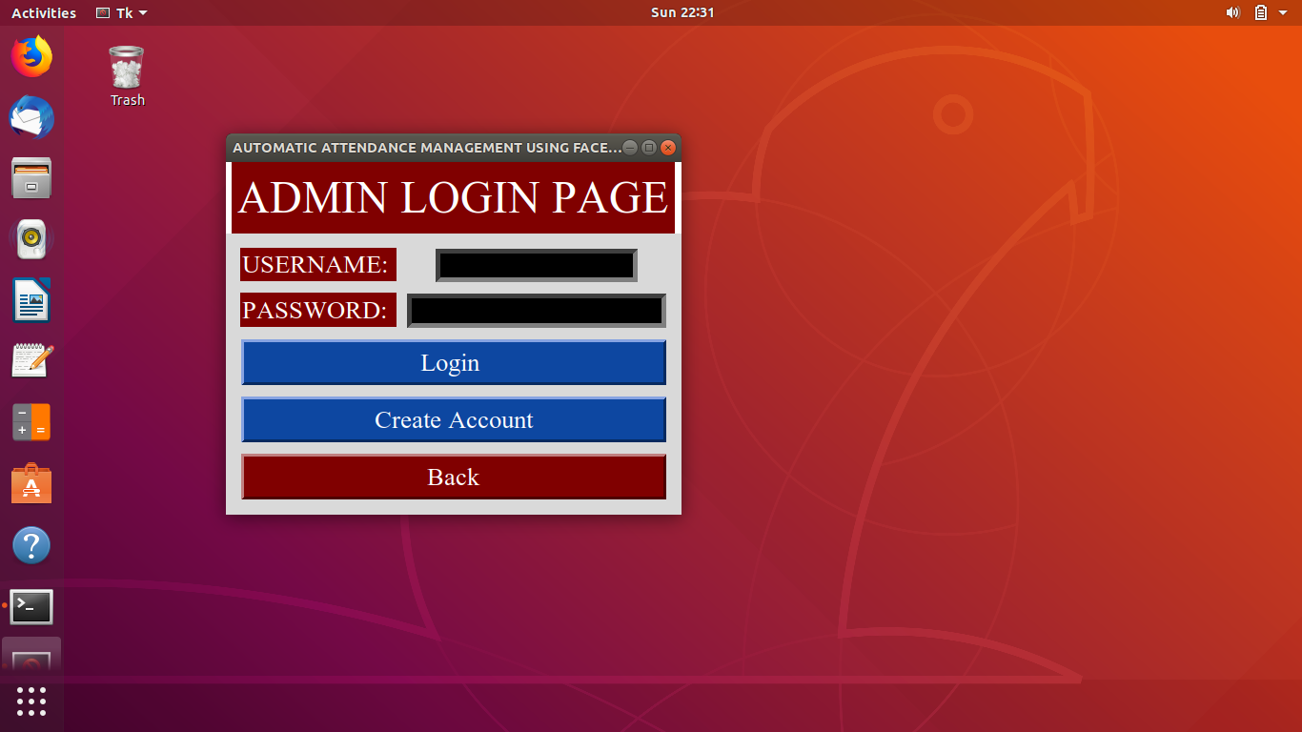

If there is an existing admin, they may log in with their username (email address) and password. The options available after successful login of the administrator are shown below.

Only the administrator has access to these functions.

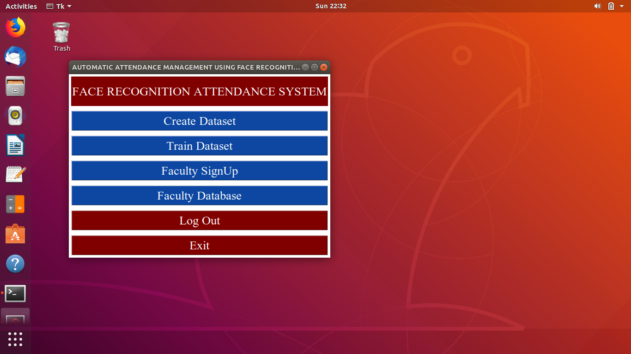

The Create Dataset button brings up the terminal and asks for an ID, then opens a webcam for capturing the images. The Train Dataset invokes the trainer module and the data captured in the Create Dataset click is trained by the algorithms mentioned above. The functions of these buttons are explained in a later chapter in more detail.

Also, it is here that new faculty members are enrolled by clicking the faculty signup button, which brings up the following screens:

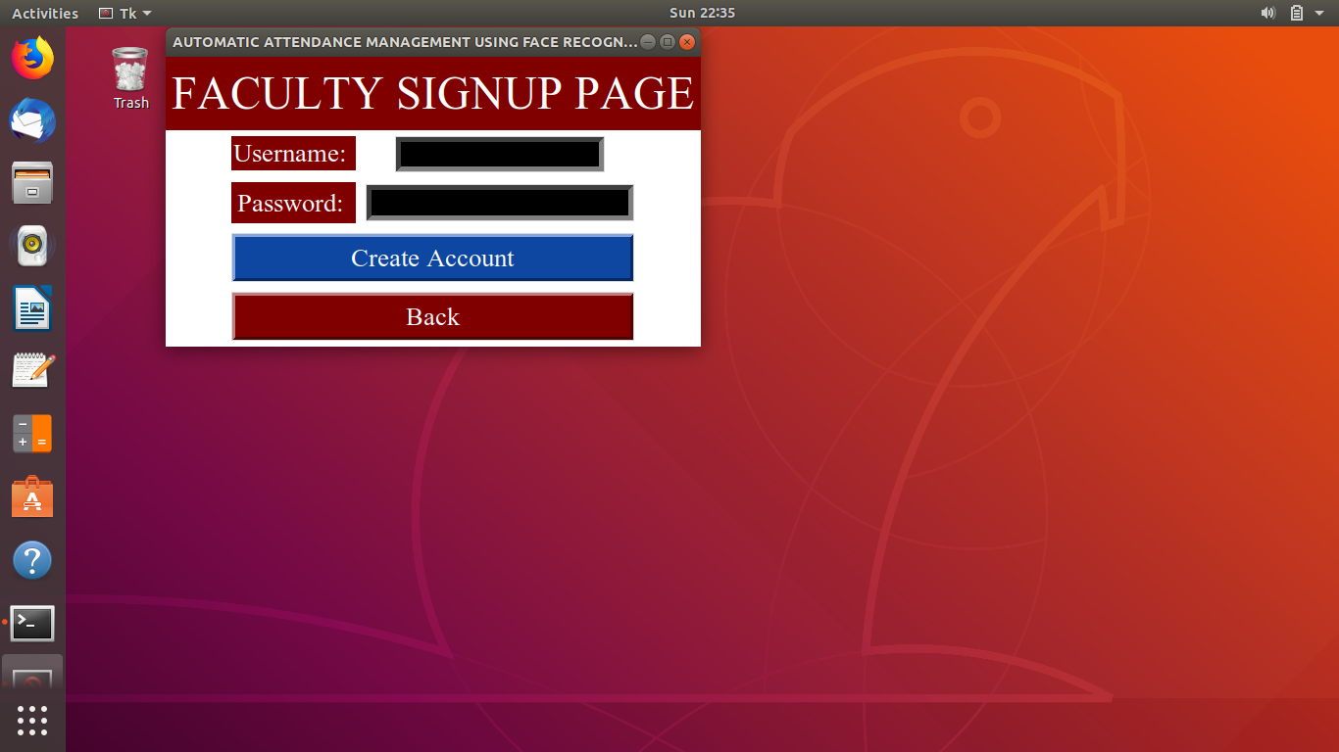

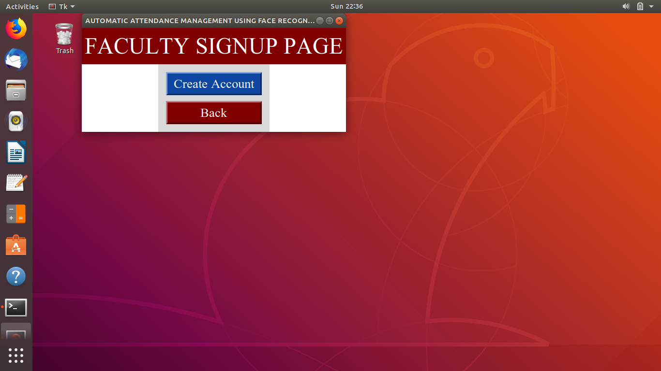

Faculty Database button invokes the SQLite Database backend. This function is also explained in a later chapter.

Let us again take a look at the first page:



On clicking faculty button, the faculty is given the option to log in (the account for faculty should already have been created on admin part).

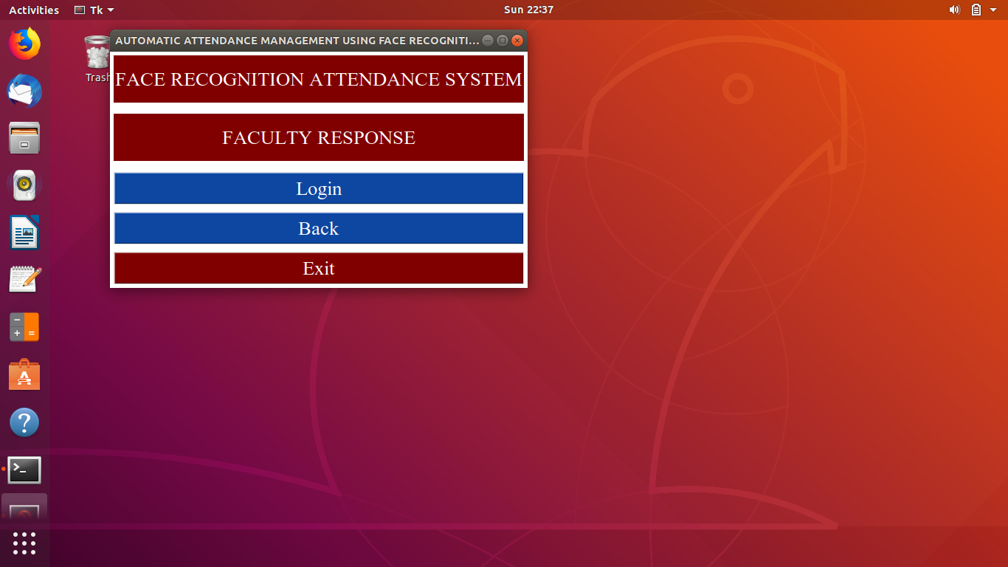

On successful login, the following screen is shown:

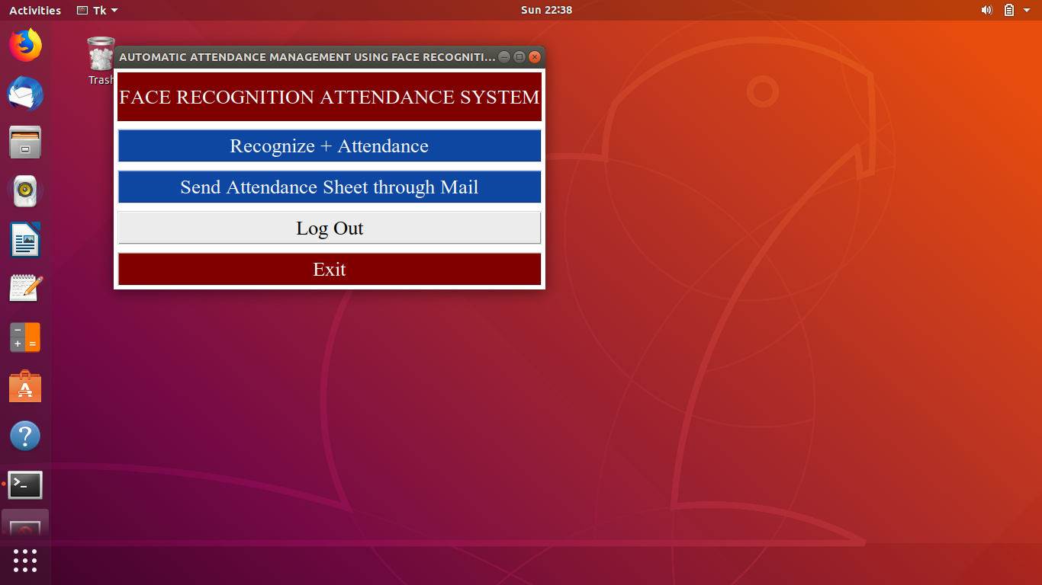

Here there are two options: Recognize+Attendance, which does the job of recognizing the faces of students with the help of a webcam, and Send Attendance Sheet Through Mail, which sends the excel sheet generated to the administrators via email.

In the first page, there is also an option called ‘student’, as shown below:



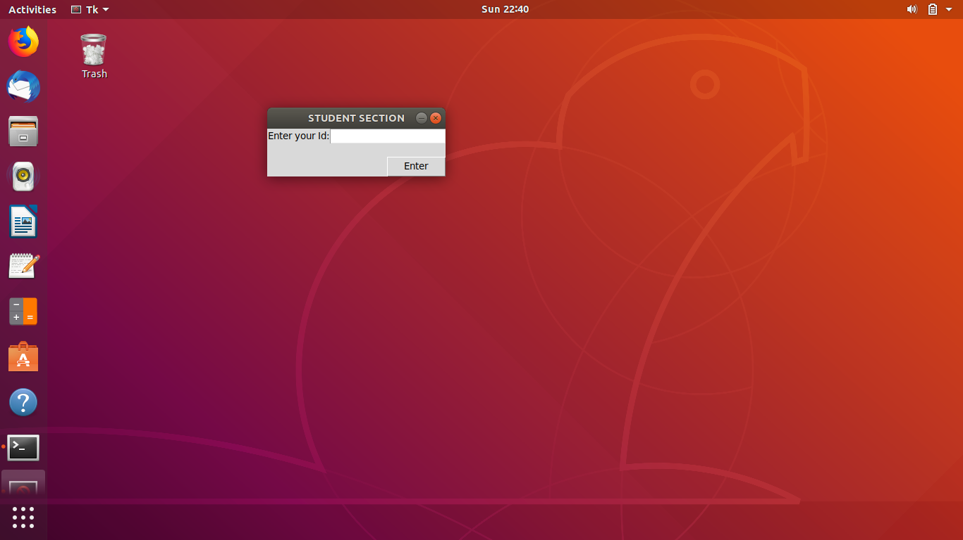

On entering the ID, the attendance sheet opens for the student to check his/her attendance.

CHAPTER 4:

Implementation

4.1 Implementation Approaches

Whole of the implementation has been done in the python programming language. A procedural approach has been followed in which scripts work as procedures and manipulate the data. Procedural approach was chosen keeping in mind the relative simplicity of the system that has been developed.

What follows in the next section is the complete source code listing of the program. Comments have been added wherever applicable to clarify the meaning of the code. A brief description of the main functionality of the script has been provided before its code.

4.2 Coding Details

The complete source code of the program has been provided below. The reader can use the Figure-8 in conjunction with the following material to gain a more rigorous understanding of the system.

**page1.py** – This is the script which is run to start the system. This is a UI based script and contains various buttons and directs to other scripts.

#import tkinter as tk

from tkinter import *

import os

from datetime import datetime;

root = Tk ()

root.configure(background="white")

def function6():

root.destroy()

def function1():

root.destroy()

os.system("python3 page2.py")

def function2():

root.destroy()

os.system("python3 loginadmin.py")

def function5():

root.destroy()

os.system('python3 reports.py')

def function3():

root.destroy()

os.system('python3 s.py')

root.title("AUTOMATIC ATTENDANCE MANAGEMENT USING FACE RECOGNITION")

Button(root,text="Faculty",font=("times new roman",20),bg="#0D47A1",fg='white',command=function1).grid(row=3,columnspan=2,sticky=W+E+N+S,padx=5,pady=5)

Button(root,text="Admin",font=("times new roman",20),bg="#0D47A1",fg='white',command=function2).grid(row=4,columnspan=2,sticky=N+E+W+S,padx=5,pady=5)

Button(root,text="Student",font=("times new roman",20),bg="#0D47A1",fg='white',command=function3).grid(row=5,columnspan=2,sticky=N+E+W+S,padx=5,pady=5)

Button(root,text="Exit",font=('times new roman',20),bg="maroon",fg="white",command=function6).grid(row=9,columnspan=2,sticky=N+E+W+S,padx=5,pady=5)

Button(root,text="Project Reports",font=('times new roman',20),bg="#0D47A1",fg="white",command=function5).grid(row=8,columnspan=2,sticky=N+E+W+S,padx=5,pady=5)

Label(root, text="FACE RECOGNITION ATTENDANCE SYSTEM",font=("times new roman",20),fg="white",bg="maroon",height=2).grid(row=0,rowspan=2,columnspan=2,sticky=N+E+W+S,padx=5,pady=5)

root.mainloop()

**loginadmin.py** – Provides options for administrators to log in or create a new account. This script interacts with the SQLite Admin Database.

from tkinter import *

from tkinter import messagebox as ms

import sqlite3

import os

# make database and users (if not exists already) table at programme start up

with sqlite3.connect('databaseadmin.db') as db:

c = db.cursor()

c.execute('CREATE TABLE IF NOT EXISTS user (username TEXT NOT NULL ,password TEX NOT NULL);')

db.commit()

db.close()

# root = tk.Tk ()

# root.configure(background="white")

# title("AUTOMATIC ATTENDANCE MANAGEMENT USING FACE RECOGNITION")

#main Class

class main:

def __init__(self,master):

# Window

self.master = master

# Some Usefull variables

self.username = StringVar()

self.password = StringVar()

self.n_username = StringVar()

self.n_password = StringVar()

#Create Widgets

self.widgets()

#Login Function

def login(self):

#Establish Connection

with sqlite3.connect('databaseadmin.db') as db:

c = db.cursor()

#Find user If there is any take proper action

find_user = ('SELECT * FROM user WHERE username = ? and password = ?')

c.execute(find_user,[(self.username.get()),(self.password.get())])

result = c.fetchall()

if result:

#self.logf.pack_forget()

#self.head['text'] = self.username.get() + '\n Loged In'

#self.head['pady'] = 150

root.destroy()

os.system('python3 firstpage1.py')

else:

ms.showerror('Oops!','Username Not Found.')

def new_user(self):

#Establish Connection

with sqlite3.connect('databaseadmin.db') as db:

c = db.cursor()

#Find Existing username if any take proper action

find_user = ('SELECT * FROM user WHERE username = ?')

c.execute(find_user,[(self.username.get())])

if c.fetchall():

ms.showerror('Error!','Username Taken Try a Diffrent One.')

else:

ms.showinfo('Success!','Account Created!')

self.log()

#Create New Account

insert = 'INSERT INTO user(username,password) VALUES(?,?)'

c.execute(insert,[(self.n_username.get()),(self.n_password.get())])

db.commit()

#Frame Packing Methords

def log(self):

self.username.set('')

self.password.set('')

self.crf.pack_forget()

self.head['text'] = 'ADMIN LOGIN'

self.logf.pack()

def cr(self):

self.n_username.set('')

self.n_password.set('')

self.logf.pack_forget()

self.head['text'] = 'ADMIN SIGNUP PAGE'

self.crf.pack()

def close_window(self):

root.destroy()

os.system("python3 page1.py")

#Draw Widgets

def widgets(self):

self.head = Label(self.master,text = 'ADMIN LOGIN PAGE',font = ('times new roman',35),padx=5,pady = 10,bg="maroon",fg="white")

self.head.pack()

self.logf = Frame(self.master,padx =10,pady = 10)

Label(self.logf,text = 'USERNAME: ',font = ('times new roman',20),bg="maroon",fg="white").grid(row=1,sticky = N+E+W+S,padx=5,pady=5)

Entry(self.logf,textvariable = self.username,bd = 5,font = ('times new roman',15),bg="black",fg="white").grid(row=1,rowspan=2,columnspan=2,column=2,padx=5,pady=5)

Label(self.logf,text = 'PASSWORD: ',font = ('times new roman',20),bg="maroon",fg="white").grid(row=3,sticky = N+E+W+S,padx=5,pady=5)

Entry(self.logf,textvariable = self.password,bd = 5,font = ('',15),show = '*',bg="black",fg="white").grid(row=3,rowspan=2,columnspan=1,column=2,padx=5,pady=5)

Button(self.logf,text = 'Login ',bd = 3 ,font = ('times new roman',20),padx=5,pady=5,command=self.login,bg="#0D47A1",fg="white").grid(row=7,columnspan=5,sticky=N+E+W+S,padx=5,pady=5)

Button(self.logf,text = ' Create Account ',bd = 3 ,font = ('times new roman',20),padx=5,pady=5,command=self.cr,bg="#0D47A1",fg="white").grid(row=9,columnspan=5,sticky=N+E+W+S,padx=5,pady=5)

Button(self.logf,text = ' Back ',bd = 3 ,font = ('times new roman',20),padx=5,pady=5,bg="maroon",fg="white",command=self.close_window).grid(row=11,columnspan=5,sticky=N+E+W+S,padx=5,pady=5)

self.logf.pack()

self.crf = Label(self.master,text='FACULTY SIGNUP PAGE',font=('times new roman',35),padx =5,pady = 10,bg='white',fg='white')

Label(self.crf,text = 'Username: ',font = ('times new roman',20),bg='maroon',fg='white').grid(row=1,sticky = N+E+W+S,padx=5,pady=5)

Entry(self.crf,textvariable = self.n_username,bd = 5,font = ('times new roman',15),bg='black',fg='white').grid(row=1,rowspan=2,columnspan=2,column=2,padx=5,pady=5)

Label(self.crf,text = 'Password: ',font = ('times new roman',20),pady=5,padx=5,bg='maroon',fg='white').grid(row=3,sticky = N+E+W+S,padx=5,pady=5)

Entry(self.crf,textvariable = self.n_password,bd = 5,font = ('',15),show = '*',bg='black',fg='white').grid(row=3,column=2,rowspan=2,columnspan=1,padx=5,pady=5)

Button(self.crf,text = 'Create Account',bd = 3 ,font = ('times new roman',20),padx=5,pady=5,command=self.new_user,bg="#0D47A1",fg="white").grid(row=9,columnspan=5,sticky=N+E+W+S,padx=5,pady=5)

#Button(self.crf,text = 'Go to Login',bd = 3 ,font = ('times new roman',20),padx=5,pady=5,command=self.log,bg="#0D47A1",fg="white").grid(row=11,columnspan=5,sticky=N+E+W+S,padx=5,pady=5)

Button(self.crf,text = ' Back ',bd = 3 ,font = ('times new roman',20),padx=5,pady=5,bg="maroon",fg="white",command=self.close_window).grid(row=13,columnspan=5,sticky=N+E+W+S,padx=5,pady=5)

#create window and application object

root = Tk()

root.title("AUTOMATIC ATTENDANCE MANAGEMENT USING FACE RECOGNITION")

root.configure(background="white")

#Button(root,text = ' Back ',bd = 3 ,font = ('times new roman',20),padx=5,pady=5,bg="maroon",fg="white").grid(row=13,columnspan=5,sticky=N+E+W+S,padx=5,pady=5)

main(root)

root.mainloop()

**firstpage1.py** – On successful login of administrator, the program is directed to this script. This script contains the options for capturing the images of the students faces and training the dataset, and signing up (creating new accounts) of the faculty. The administrator has sole access to these functions.

#import module from tkinter for UI

from tkinter import *

from playsound import playsound

import os

import subprocess,sys

from datetime import datetime;

#from PIL import ImageTk, Image

#creating instance of TK

root=Tk()

photo = PhotoImage('imagexav.png')

l = Label(image = photo)

#l.pack()

root.configure(background="white")

#root.geometry("300x300")

def function1():

playsound('TextTo.mp3')

os.system("python3 dataset_capture.py")

playsound('S.mp3')

def function2():

os.system("python3 training_dataSet.py")

playsound('train.mp3')

def function3():

os.system("xdg-open databasefaculty.db")

playsound('sound.mp3')

def function6():

root.destroy()

os.system('python3 loginadmin.py')

def function5():

root.destroy()

os.system('python reports.py')

def function7():

root.destroy()

os.system('python3 fsignup.py')

def function():

root.destroy()

#setting title for the window

root.title("AUTOMATIC ATTENDANCE MANAGEMENT USING FACE RECOGNITION")

#creating a text label

Label(root, text="FACE RECOGNITION ATTENDANCE SYSTEM",font=("times new roman",20),fg="white",bg="maroon",height=2).grid(row=0,rowspan=2,columnspan=2,sticky=N+E+W+S,padx=5,pady=5)

#creating first button

Button(root,text="Create Dataset",font=("times new roman",20),bg="#0D47A1",fg='white',command=function1).grid(row=3,columnspan=2,sticky=W+E+N+S,padx=5,pady=5)

#creating second button

Button(root,text="Train Dataset",font=("times new roman",20),bg="#0D47A1",fg='white',command=function2).grid(row=4,columnspan=2,sticky=N+E+W+S,padx=5,pady=5)

Button(root,text="Faculty SignUp",font=('times new roman',20),bg="#0D47A1",fg="white",command=function7).grid(row=5,columnspan=2,sticky=N+E+W+S,padx=5,pady=5)

#creating third button

Button(root,text="Faculty Database",font=('times new roman',20),bg="#0D47A1",fg="white",command=function3).grid(row=6,columnspan=2,sticky=N+E+W+S,padx=5,pady=5)

Button(root,text="Log Out",font=('times new roman',20),bg="maroon",fg="white",command=function6).grid(row=10,columnspan=2,sticky=N+E+W+S,padx=5,pady=5)

Button(root,text="Exit",font=('times new roman',20),bg="maroon",fg="white",command=function).grid(row=12,columnspan=2,sticky=N+E+W+S,padx=5,pady=5)

root.mainloop()

**fsignup.py** – provides options for creating new faculty members. Interacts with the SQL Faculty Database.

from tkinter import *

from tkinter import messagebox as ms

import sqlite3

import os

# make database and users (if not exists already) table at programme start up

with sqlite3.connect('databasefaculty.db') as db:

c = db.cursor()

c.execute('CREATE TABLE IF NOT EXISTS user (username TEXT NOT NULL ,password TEX NOT NULL);')

db.commit()

db.close()

# root = tk.Tk ()

# root.configure(background="white")

# title("AUTOMATIC ATTENDANCE MANAGEMENT USING FACE RECOGNITION")

#main Class

class main:

def __init__(self,master):

# Window

self.master = master

# Some Usefull variables

self.username = StringVar()

self.password = StringVar()

self.n_username = StringVar()

self.n_password = StringVar()

#Create Widgets

self.widgets()

#Login Function

def login(self):

#Establish Connection

with sqlite3.connect('databasefaculty.db') as db:

c = db.cursor()

#Find user If there is any take proper action

find_user = ('SELECT * FROM user WHERE username = ? and password = ?')

c.execute(find_user,[(self.username.get()),(self.password.get())])

result = c.fetchall()

if result:

#self.logf.pack_forget()

#self.head['text'] = self.username.get() + '\n Loged In'

#self.head['pady'] = 150

root.destroy()

os.system('python3 firstpage1.py')

else:

ms.showerror('Oops!','Username Not Found.')

def new_user(self):

#Establish Connection

with sqlite3.connect('databasefaculty.db') as db:

c = db.cursor()

#Find Existing username if any take proper action

find_user = ('SELECT * FROM user WHERE username = ?')

c.execute(find_user,[(self.username.get())])

if c.fetchall():

ms.showerror('Error!','Username Taken Try a Diffrent One.')

else:

ms.showinfo('Success!','Account Created!')

self.log()

#Create New Account

insert = 'INSERT INTO user(username,password) VALUES(?,?)'

c.execute(insert,[(self.n_username.get()),(self.n_password.get())])

db.commit()

#Frame Packing Methords

def log(self):

self.username.set('')

self.password.set('')

self.crf.pack_forget()

self.head['text'] = 'FACULTY LOGIN'

self.logf.pack()

def cr(self):

self.n_username.set('')

self.n_password.set('')

self.logf.pack_forget()

self.head['text'] = 'FACULTY SIGNUP PAGE'

self.crf.pack()

def close_window(self):

root.destroy()

os.system("python3 firstpage1.py")

#Draw Widgets

def widgets(self):

self.head = Label(self.master,text = 'FACULTY SIGNUP PAGE',font = ('times new roman',35),padx=5,pady = 10,bg="maroon",fg="white")

self.head.pack()

self.logf = Frame(self.master,padx =10,pady = 10)

#Label(self.logf,text = 'USERNAME: ',font = ('times new roman',20),bg="maroon",fg="white").grid(row=1,sticky = N+E+W+S,padx=5,pady=5)

#Entry(self.logf,textvariable = self.username,bd = 5,font = ('times new roman',15),bg="black",fg="white").grid(row=1,rowspan=2,columnspan=2,column=2,padx=5,pady=5)

#Label(self.logf,text = 'PASSWORD: ',font = ('times new roman',20),bg="maroon",fg="white").grid(row=3,sticky = N+E+W+S,padx=5,pady=5)

#Entry(self.logf,textvariable = self.password,bd = 5,font = ('',15),show = '*',bg="black",fg="white").grid(row=3,rowspan=2,columnspan=1,column=2,padx=5,pady=5)

#Button(self.logf,text = 'Login ',bd = 3 ,font = ('times new roman',20),padx=5,pady=5,command=self.login,bg="#0D47A1",fg="white").grid(row=7,columnspan=5,sticky=N+E+W+S,padx=5,pady=5)

Button(self.logf,text = ' Create Account ',bd = 3 ,font = ('times new roman',20),padx=5,pady=5,command=self.cr,bg="#0D47A1",fg="white").grid(row=9,columnspan=5,sticky=N+E+W+S,padx=5,pady=5)

Button(self.logf,text = ' Back ',bd = 3 ,font = ('times new roman',20),padx=5,pady=5,bg="maroon",fg="white",command=self.close_window).grid(row=11,columnspan=5,sticky=N+E+W+S,padx=5,pady=5)

self.logf.pack()

self.crf = Label(self.master,text='FACULTY SIGNUP PAGE',font=('times new roman',35),padx =5,pady = 10,bg='white',fg='white')

Label(self.crf,text = 'Username: ',font = ('times new roman',20),bg='maroon',fg='white').grid(row=1,sticky = N+E+W+S,padx=5,pady=5)

Entry(self.crf,textvariable = self.n_username,bd = 5,font = ('times new roman',15),bg='black',fg='white').grid(row=1,rowspan=2,columnspan=2,column=2,padx=5,pady=5)

Label(self.crf,text = 'Password: ',font = ('times new roman',20),pady=5,padx=5,bg='maroon',fg='white').grid(row=3,sticky = N+E+W+S,padx=5,pady=5)

Entry(self.crf,textvariable = self.n_password,bd = 5,font = ('',15),show = '*',bg='black',fg='white').grid(row=3,column=2,rowspan=2,columnspan=1,padx=5,pady=5)

Button(self.crf,text = 'Create Account',bd = 3 ,font = ('times new roman',20),padx=5,pady=5,command=self.new_user,bg="#0D47A1",fg="white").grid(row=9,columnspan=5,sticky=N+E+W+S,padx=5,pady=5)

#Button(self.crf,text = 'Go to Login',bd = 3 ,font = ('times new roman',20),padx=5,pady=5,command=self.log,bg="#0D47A1",fg="white").grid(row=11,columnspan=5,sticky=N+E+W+S,padx=5,pady=5)

Button(self.crf,text = ' Back ',bd = 3 ,font = ('times new roman',20),padx=5,pady=5,bg="maroon",fg="white",command=self.close_window).grid(row=13,columnspan=5,sticky=N+E+W+S,padx=5,pady=5)

#create window and application object

root = Tk()

root.title("AUTOMATIC ATTENDANCE MANAGEMENT USING FACE RECOGNITION")

root.configure(background="white")

#Button(root,text = ' Back ',bd = 3 ,font = ('times new roman',20),padx=5,pady=5,bg="maroon",fg="white").grid(row=13,columnspan=5,sticky=N+E+W+S,padx=5,pady=5)

main(root)

root.mainloop()

**dataset_capture.py** – captures the images of students’ faces.

# Import OpenCV2 for image processing

import cv2

import os

from playsound import playsound

def assure_path_exists(path):

dir = os.path.dirname(path)

if not os.path.exists(dir):

os.makedirs(dir)

playsound('id.mp3')

face_id=input('enter your id')

# os.system("python speech.py")

# Start capturing video

vid_cam = cv2.VideoCapture(0)

# Detect object in video stream using Haarcascade Frontal Face

face_detector = cv2.CascadeClassifier('haarcascade_frontalface_default.xml')

# Initialize sample face image

count = 0

assure_path_exists("dataset/")

# Start looping

while(True):

# Capture video frame

_, image_frame = vid_cam.read()

# Convert frame to grayscale

gray = cv2.cvtColor(image_frame, cv2.COLOR_BGR2GRAY)

# Detect frames of different sizes, list of faces rectangles

faces = face_detector.detectMultiScale(gray, 1.3, 5)

# Loops for each faces

for (x,y,w,h) in faces:

# Crop the image frame into rectangle

cv2.rectangle(image_frame, (x,y), (x+w,y+h), (255,0,0), 2)

# Increment sample face image

count += 1

# Save the captured image into the datasets folder

cv2.imwrite("dataset/User." + str(face_id) + '.' + str(count) + ".jpg", gray[y:y+h,x:x+w])

# Display the video frame, with bounded rectangle on the person's face

cv2.imshow('frame', image_frame)

# To stop taking video, press 'q' for at least 100ms

if cv2.waitKey(100) & 0xFF == ord('q'):

break

# If image taken reach 100, stop taking video

elif count>=15:

print("Successfully Captured")

break

# Stop video

vid_cam.release()

# Close all started windows

cv2.destroyAllWindows()

**train_dataset.py** – Takes the captured dataset as input and trains them using LBPH Recognizer.

import os,cv2;

import numpy as np

from PIL import Image;

recognizer = cv2.face.LBPHFaceRecognizer_create()

detector= cv2.CascadeClassifier("haarcascade_frontalface_default.xml");

def getImagesAndLabels(path):

#get the path of all the files in the folder

imagePaths=[os.path.join(path,f) for f in os.listdir(path)]

#create empth face list

faceSamples=[]

#create empty ID list

Ids=[]

#now looping through all the image paths and loading the Ids and the images

for imagePath in imagePaths:

#loading the image and converting it to gray scale

pilImage=Image.open(imagePath).convert('L')

#Now we are converting the PIL image into numpy array

imageNp=np.array(pilImage,'uint8')

#getting the Id from the image

Id=int(os.path.split(imagePath)[-1].split(".")[1])

# extract the face from the training image sample

faces=detector.detectMultiScale(imageNp)

#If a face is there then append that in the list as well as Id of it

for (x,y,w,h) in faces:

faceSamples.append(imageNp[y:y+h,x:x+w])

Ids.append(Id)

return faceSamples,Ids

faces,Ids = getImagesAndLabels('dataset')

s = recognizer.train(faces, np.array(Ids))

print("Successfully trained")

recognizer.write('trainer.yml')

**s.py** – provides option for the student in page 1 to enter his/her ID and check the attendance sheet.

from tkinter import *

# also import the themed tkinter for good looking widgets (not obligatory)

from tkinter import ttk

import os

import tkinter

from tkinter import messagebox

window = Tk()

window.title("STUDENT SECTION")

window.resizable(0, 0)

def function1():

text = entry_id.get() # get the text from entry

# format the text on the invisible label you created above

if text == '1' or text == '2' or text == '3' or text == '4':

window.destroy()

os.system('python3 student.py')

else:

root = tkinter.Tk()

root.withdraw()

messagebox.showinfo("Student Section", "Your ID is not correct ")

# prohibit resizing the window

text = ttk.Label(window, text='Enter your Id:')

text.grid(row=0, column=0, sticky=W)

#label_result = ttk.Label(window, text='Result:')

# label_result.grid(row=1, column=0, sticky=W)

# create an id for the invisible label where will be displayed the text in the box

label = StringVar()

# create the invisible label

invisible_label = ttk.Label(window, text='', textvariable=label)

invisible_label.grid(row=1, column=1, sticky=E)

# create an id for your entry, this helps getting the text

entry_id = StringVar()

entry = ttk.Entry(

window, textvariable=entry_id, justify=RIGHT)

entry.grid(row=0, column=1, sticky=E)

button = ttk.Button(window, text='Enter', command=function1)

button.grid(row=2, column=1, sticky=E)

# handle the enter key event of your keyboard

#window.bind("<Return>", self.clicked)

# bind the action of the left button of your mouse to the button assuming your primary click button is the left one.

#button.bind("<Button-1>", self.clicked)

# call the mainloop function so the window won't fade after the first execution

window.mainloop()

**page2.py** – simple GUI based page that directs faculty to log in to their accounts.

from tkinter import *

import os

from datetime import datetime;

root = Tk ()

root.configure(background="white")

def function6():

root.destroy()

def function1():

root.destroy()

os.system("python3 loginfaculty.py")

def function2():

root.destroy()

os.system("python3 page1.py")

root.title("AUTOMATIC ATTENDANCE MANAGEMENT USING FACE RECOGNITION")

Button(root,text="Login",font=("times new roman",20),bg="#0D47A1",fg='white',command=function1).grid(row=4,columnspan=2,sticky=W+E+N+S,padx=5,pady=5)

Button(root,text="Back",font=("times new roman",20),bg="#0D47A1",fg='white',command=function2).grid(row=6,columnspan=2,sticky=N+E+W+S,padx=5,pady=5)

Button(root,text="Exit",font=('times new roman',20),bg="maroon",fg="white",command=function6).grid(row=9,columnspan=2,sticky=N+E+W+S,padx=5,pady=5)

Label(root, text="FACE RECOGNITION ATTENDANCE SYSTEM",font=("times new roman",20),fg="white",bg="maroon",height=2).grid(row=0,rowspan=2,columnspan=2,sticky=N+E+W+S,padx=5,pady=5)

Label(root, text="FACULTY RESPONSE",font=("times new roman",20),fg="white",bg="maroon",height=2).grid(row=2,rowspan=2,columnspan=5,sticky=N+E+W+S,padx=5,pady=10)

root.mainloop()

**loginfaculty.py** – Gives faculty the option to log in to their accounts. Interacts with the SQL Faculty Database.

from tkinter import *

from tkinter import messagebox as ms

import sqlite3

import os

# make database and users (if not exists already) table at programme start up

with sqlite3.connect('databasefaculty.db') as db:

c = db.cursor()

c.execute('CREATE TABLE IF NOT EXISTS user (username TEXT NOT NULL ,password TEX NOT NULL);')

db.commit()

db.close()

# root = tk.Tk ()

# root.configure(background="white")

# title("AUTOMATIC ATTENDANCE MANAGEMENT USING FACE RECOGNITION")

#main Class

class main:

def __init__(self,master):

# Window

self.master = master

# Some Usefull variables

self.username = StringVar()

self.password = StringVar()

self.n_username = StringVar()

self.n_password = StringVar()

#Create Widgets

self.widgets()

#Login Function

def login(self):

#Establish Connection

with sqlite3.connect('databasefaculty.db') as db:

c = db.cursor()

#Find user If there is any take proper action

find_user = ('SELECT * FROM user WHERE username = ? and password = ?')

c.execute(find_user,[(self.username.get()),(self.password.get())])

result = c.fetchall()

if result:

#self.logf.pack_forget()

#self.head['text'] = self.username.get() + '\n Loged In'

#self.head['pady'] = 150

root.destroy()

os.system('python3 firstpage.py')

else:

ms.showerror('Oops!','Username Not Found.')

def new_user(self):

#Establish Connection

with sqlite3.connect('databasefaculty.db') as db:

c = db.cursor()

#Find Existing username if any take proper action

find_user = ('SELECT * FROM user WHERE username = ?')

c.execute(find_user,[(self.username.get())])

if c.fetchall():

ms.showerror('Error!','Username Taken Try a Diffrent One.')

else:

ms.showinfo('Success!','Account Created!')

self.log()

#Create New Account

insert = 'INSERT INTO user(username,password) VALUES(?,?)'

c.execute(insert,[(self.n_username.get()),(self.n_password.get())])

db.commit()

#Frame Packing Methords

def log(self):

self.username.set('')

self.password.set('')

self.crf.pack_forget()

self.head['text'] = 'LOGIN'

self.logf.pack()

def cr(self):

self.n_username.set('')

self.n_password.set('')

self.logf.pack_forget()

self.head['text'] = 'FACULTY SIGNUP PAGE'

self.crf.pack()

def function1(self):

root.destroy()

os.system("python3 page1.py")

#Draw Widgets

def widgets(self):

self.head = Label(self.master,text = 'FACULTY LOGIN PAGE',font = ('times new roman',35),padx=5,pady = 10,bg="maroon",fg="white")

self.head.pack()

self.logf = Frame(self.master,padx =10,pady = 10)

Label(self.logf,text = 'USERNAME: ',font = ('times new roman',20),bg="maroon",fg="white").grid(row=1,sticky = N+E+W+S,padx=5,pady=5)

Entry(self.logf,textvariable = self.username,bd = 5,font = ('times new roman',15),bg="black",fg="white").grid(row=1,rowspan=2,columnspan=2,column=2,padx=5,pady=5)

Label(self.logf,text = 'PASSWORD: ',font = ('times new roman',20),bg="maroon",fg="white").grid(row=3,sticky = N+E+W+S,padx=5,pady=5)

Entry(self.logf,textvariable = self.password,bd = 5,font = ('',15),show = '*',bg="black",fg="white").grid(row=3,rowspan=2,columnspan=1,column=2,padx=5,pady=5)

Button(self.logf,text = 'Login ',bd = 3 ,font = ('times new roman',20),padx=5,pady=5,command=self.login,bg="#0D47A1",fg="white").grid(row=7,columnspan=5,sticky=N+E+W+S,padx=5,pady=5)

#Button(self.logf,text = ' Create Account ',bd = 3 ,font = ('times new roman',20),padx=5,pady=5,command=self.cr,bg="#0D47A1",fg="white").grid(row=9,columnspan=5,sticky=N+E+W+S,padx=5,pady=5)

Button(self.logf,text = ' Back ',bd = 3 ,font = ('times new roman',20),padx=5,pady=5,bg="maroon",fg="white",command=self.function1).grid(row=11,columnspan=5,sticky=N+E+W+S,padx=5,pady=5)

self.logf.pack()

self.crf = Label(self.master,text='FACULTY SIGNUP PAGE',font=('times new roman',35),padx =5,pady = 10,bg='white',fg='white')

Label(self.crf,text = 'Username: ',font = ('times new roman',20),bg='maroon',fg='white').grid(row=1,sticky = N+E+W+S,padx=5,pady=5)

Entry(self.crf,textvariable = self.n_username,bd = 5,font = ('times new roman',15),bg='black',fg='white').grid(row=1,rowspan=2,columnspan=2,column=2,padx=5,pady=5)

Label(self.crf,text = 'Password: ',font = ('times new roman',20),pady=5,padx=5,bg='maroon',fg='white').grid(row=3,sticky = N+E+W+S,padx=5,pady=5)

Entry(self.crf,textvariable = self.n_password,bd = 5,font = ('',15),show = '*',bg='black',fg='white').grid(row=3,column=2,rowspan=2,columnspan=1,padx=5,pady=5)

Button(self.crf,text = 'Create Account',bd = 3 ,font = ('times new roman',20),padx=5,pady=5,command=self.new_user,bg="#0D47A1",fg="white").grid(row=9,columnspan=5,sticky=N+E+W+S,padx=5,pady=5)

Button(self.crf,text = 'Go to Login',bd = 3 ,font = ('times new roman',20),padx=5,pady=5,command=self.log,bg="#0D47A1",fg="white").grid(row=11,columnspan=5,sticky=N+E+W+S,padx=5,pady=5)

Button(self.crf,text = ' Back ',bd = 3 ,font = ('times new roman',20),padx=5,pady=5,bg="maroon",fg="white",command=self.function1).grid(row=13,columnspan=5,sticky=N+E+W+S,padx=5,pady=5)

#create window and application object

root = Tk()

root.title("AUTOMATIC ATTENDANCE MANAGEMENT USING FACE RECOGNITION")

root.configure(background="white")

main(root)

root.mainloop()

**firstpage.py** – provides the options of recognizing the students’ faces and sending the generated attendance sheet through mail. This page is accessible only to the faculty.

#import module from tkinter for UI

from tkinter import *

from playsound import playsound

import os

import subprocess,sys

from datetime import datetime;

#from PIL import ImageTk, Image

#creating instance of TK

root=Tk()

photo = PhotoImage('imagexav.png')

l = Label(image = photo)

#l.pack()

root.configure(background="white")

#root.geometry("300x300")

def function1():

playsound('TextTo.mp3')

os.system("python dataset_capture.py")

playsound('S.mp3')

def function2():

os.system("python training_dataSet.py")

playsound('train.mp3')

def function3():

os.system("python3 recognizer.py")

playsound('sound.mp3')

def function6():

root.destroy()

os.system('python3 loginfaculty.py')

def attend():

os.system('python3 m.py')

def function5():

root.destroy()

os.system('python3 reports.py')

def function():

root.destroy()

#setting title for the window

root.title("AUTOMATIC ATTENDANCE MANAGEMENT USING FACE RECOGNITION")

#creating a text label

Label(root, text="FACE RECOGNITION ATTENDANCE SYSTEM",font=("times new roman",20),fg="white",bg="maroon",height=2).grid(row=0,rowspan=2,columnspan=2,sticky=N+E+W+S,padx=5,pady=5)

#creating first button

#Button(root,text="Create Dataset",font=("times new roman",20),bg="#0D47A1",fg='white',command=function1).grid(row=3,columnspan=2,sticky=W+E+N+S,padx=5,pady=5)

#creating second button

#Button(root,text="Train Dataset",font=("times new roman",20),bg="#0D47A1",fg='white',command=function2).grid(row=4,columnspan=2,sticky=N+E+W+S,padx=5,pady=5)

#creating third button

Button(root,text="Recognize + Attendance",font=('times new roman',20),bg="#0D47A1",fg="white",command=function3).grid(row=5,columnspan=2,sticky=N+E+W+S,padx=5,pady=5)

#creating attendance button

Button(root,text="Send Attendance Sheet through Mail",font=('times new roman',20),bg="#0D47A1",fg="white",command=attend).grid(row=6,columnspan=2,sticky=N+E+W+S,padx=5,pady=5)

#Button(root,text="Project Reports",font=('times new roman',20),bg="#0D47A1",fg="white",command=function5).grid(row=8,columnspan=2,sticky=N+E+W+S,padx=5,pady=5)

Button(root,text="Log Out",font=('times new roman',20),bg="maroon",fg="white",command=function6).grid(row=10,columnspan=2,sticky=N+E+W+S,padx=5,pady=5)

Button(root,text="Exit",font=('times new roman',20),bg="maroon",fg="white",command=function).grid(row=12,columnspan=2,sticky=N+E+W+S,padx=5,pady=5)

root.mainloop()

**recognizer.py** – performs the task of recognizing the student’s faces and detecting any error or spoof. Also writes the attendance information into an excel spreadsheet.

import cv2, numpy as np;

import xlwrite

import time

import sys

from playsound import playsound

import tkinter

from tkinter import messagebox

start=time.time()

period=180

face_cas = cv2.CascadeClassifier('haarcascade_frontalface_default.xml')

cap = cv2.VideoCapture(0);

recognizer = cv2.face.LBPHFaceRecognizer_create();

recognizer.read('trainer.yml');

flag = 0;

id=0;

filename='filename';

dict = {

'item1': 1

}

#font = cv2.InitFont(cv2.cv.CV_FONT_HERSHEY_SIMPLEX, 5, 1, 0, 1, 1)

font = cv2.FONT_HERSHEY_SIMPLEX

while True:

ret, img = cap.read();

gray = cv2.cvtColor(img, cv2.COLOR_BGR2GRAY);

faces = face_cas.detectMultiScale(gray, 1.3, 7);

for (x,y,w,h) in faces:

roi_gray = gray[y:y + h, x:x + w]

cv2.rectangle(img, (x,y), (x+w, y+h), (255,0,0),2);

id,conf=recognizer.predict(roi_gray)

if(conf < 50):

if(id==1):

id='Kingshuk Mukherjee'

if((str(id)) not in dict):

filename=xlwrite.output('attendance','class1',1,id,'yes');

dict[str(id)]=str(id);

elif(id==2):

id = 'Rohan'

if ((str(id)) not in dict):

filename =xlwrite.output('attendance', 'class1', 2, id, 'yes');

dict[str(id)] = str(id);

elif(id==3):

id = 'Raveen'

if ((str(id)) not in dict):

filename =xlwrite.output('attendance', 'class1', 3, id, 'yes');

dict[str(id)] = str(id);

elif(id==4):

id = 'Sonu'

if ((str(id)) not in dict):

filename =xlwrite.output('attendance', 'class1', 4, id, 'yes');

dict[str(id)] = str(id);

else:

id = 'Unknown, can not recognize'

flag=flag+1

cv2.rectangle(img, (x,y), (x+w, y+h), (0,0,255),2);

cv2.putText(img,"Spoof Detected",(x,y-10),font,0.55,(120,255,120),1)

break

cv2.putText(img,str(id)+" "+str(conf),(x,y-10),font,0.55,(120,255,120),1)

cv2.putText(img,"Your attendance has been accepted",(x,w),font,0.55,(120,255,120),1)

image = cv2.resize(img,(1500,768))

cv2.imshow('frame',image);

#cv2.imshow('gray',gray);

#if flag == 10:

#playsound('transactionSound.mp3')

#playsound('Spoof.mp3')

if time.time()>start+period:

playsound('sound.mp3')

break;

if cv2.waitKey(100) & 0xFF == ord('q'):

break;

cap.release();

cv2.destroyAllWindows();

**xlwrite.py** – this is the only script that is not directly accessible from any of the buttons of the user interface. This script works with the recognizer.py script to generate the excel spreadsheet.

import xlwt;

from datetime import datetime;

from xlrd import open_workbook;

from xlwt import Workbook;

from xlutils.copy import copy

from pathlib import Path

'''style0 = xlwt.easyxf('font: name Times New Roman, color-index red, bold on',

num_format_str='#,##0.00')

style1 = xlwt.easyxf(num_format_str='D-MMM-YY')

wb = xlwt.Workbook()

ws = wb.add_sheet('A Test Sheet')

ws.write(0, 0, 1234.56, style0)

ws.write(1, 0, datetime.now(), style1)

ws.write(2, 0, 1)

ws.write(2, 1, 1)

ws.write(2, 2, xlwt.Formula("A3+B3"))

wb.save('example.xls')

'''

def output(filename, sheet,num, name, present):

my_file = Path(filename+str(datetime.now().date())+'.xls');

if my_file.is_file():

rb = open_workbook(filename+str(datetime.now().date())+'.xls');

book = copy(rb);

sh = book.get_sheet(0)

# file existss

else:

book = xlwt.Workbook()

sh = book.add_sheet(sheet)

style0 = xlwt.easyxf('font: name Times New Roman, color-index red, bold on',

num_format_str='#,##0.00')

style1 = xlwt.easyxf(num_format_str='D-MMM-YY')

#variables = [x, y, z]

#x_desc = 'Display'

#y_desc = 'Dominance'

#z_desc = 'Test'

#desc = [x_desc, y_desc, z_desc]

sh.write(0,0,datetime.now().date(),style1);

col1_name = 'Name'

col2_name = 'Present'

sh.write(1,0,col1_name,style0);

sh.write(1, 1, col2_name,style0);

sh.write(num+1,0,name);

sh.write(num+1, 1, present);

#You may need to group the variables together

#for n, (v_desc, v) in enumerate(zip(desc, variables)):

fullname=filename+str(datetime.now().date())+'.xls';

book.save(fullname)

return fullname;

**m.py** – Mailing script that mails the attendance sheet to the administrator accounts.

import smtplib

from email.mime.multipart import MIMEMultipart

from email.mime.text import MIMEText

from email.mime.base import MIMEBase

from email import encoders

import tkinter

from tkinter import messagebox

import sqlite3

from datetime import datetime;

final =""

final1 =""

conn=sqlite3.connect('databaseadmin.db')

c = conn.cursor()

r = ('SELECT COUNT(username) FROM user')

c.execute(r)

f = c.fetchone()

for s in f:

for i in range(1,s+1):

usern = ('SELECT username FROM user where rowid='+str(i))

c.execute(usern)

result = c.fetchone()

for row in result:

final = final + row+ " "

conn.close()

fromaddr = ""

li = list(final.split(" "))

toaddr = li

# instance of MIMEMultipart

msg = MIMEMultipart()

# storing the senders email address

msg['From'] = fromaddr

# storing the receivers email address

msg['To'] = ','.join(toaddr)

# storing the subject

msg['Subject'] = "Attendance Sheet"

# string to store the body of the mail

body = "Highly Confidential"

# attach the body with the msg instance

msg.attach(MIMEText(body, 'plain'))

# open the file to be sent

filename = "attendance"+str(datetime.now().date())+'.xls'

attachment = open("attendance"+str(datetime.now().date())+'.xls', "rb")

# instance of MIMEBase and named as p

p = MIMEBase('application', 'octet-stream')

# To change the payload into encoded form

p.set_payload((attachment).read())

# encode into base64

encoders.encode_base64(p)

p.add_header('Content-Disposition', "attachment; filename= %s" % filename)

# attach the instance 'p' to instance 'msg'

msg.attach(p)

# creates SMTP session

s = smtplib.SMTP('smtp.gmail.com', 587)

# start TLS for security

s.starttls()

# Authentication

s.login(fromaddr, "")

# Converts the Multipart msg into a string

text = msg.as_string()

# sending the mail

s.sendmail(fromaddr, toaddr, text)

# terminating the session

s.quit()

root = tkinter.Tk()

root.withdraw()

messagebox.showinfo("Msg Sent", "Your mail has been sent successfully")

CHAPTER 5:

RESULTS AND DISCUSSION

This chapter shows the results obtained by running the program. The entire flow of control has been depicted through screenshots of the system. The example run in this case has been performed on a linux system (Ubuntu 18.04).

# 5.1 Outputs

**5.1.1 Admin Block**

The program opens at page1.py, which is shown below. Firstly, the functions of the administrator block are explained.

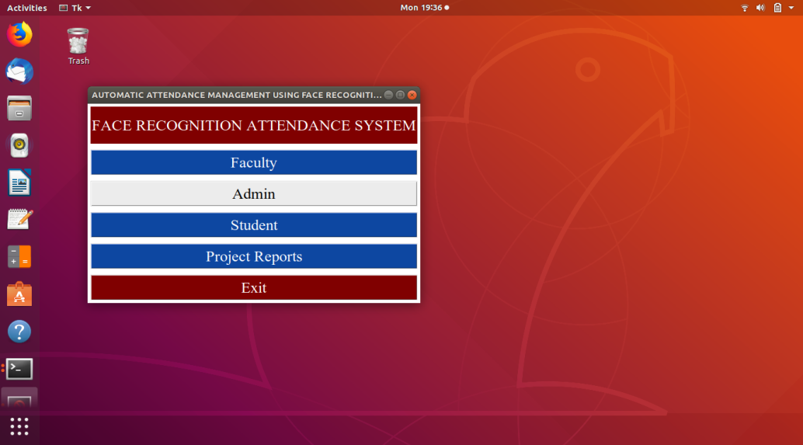

On clicking ‘Admin’, the user is given the option to log in or create a new account, as shown below. For the purpose of demonstration, we shall create a new account. We shall also show the check for wrong username.

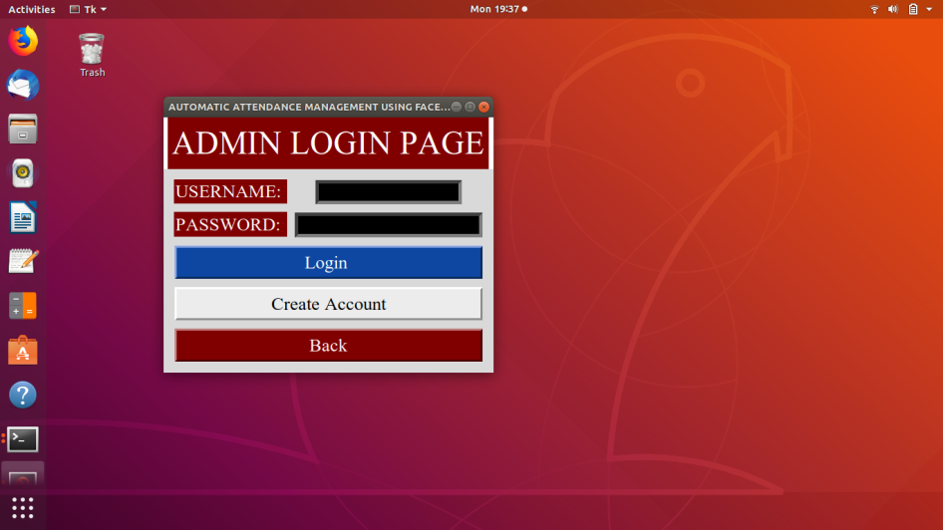

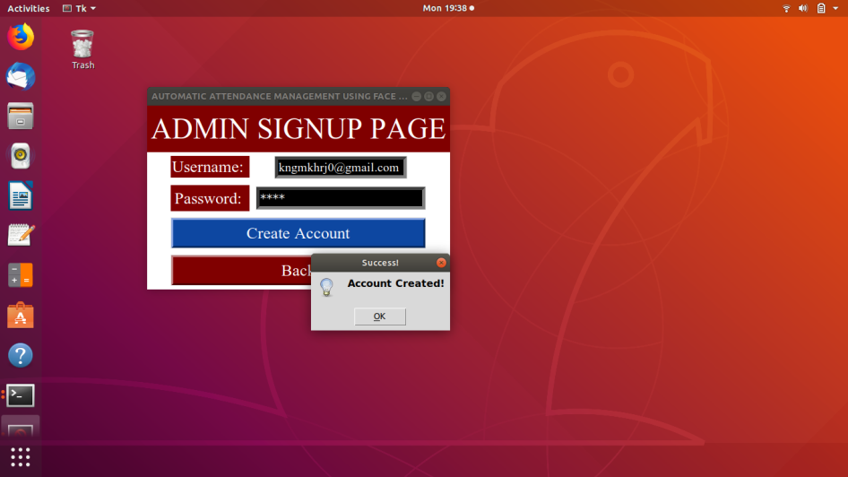

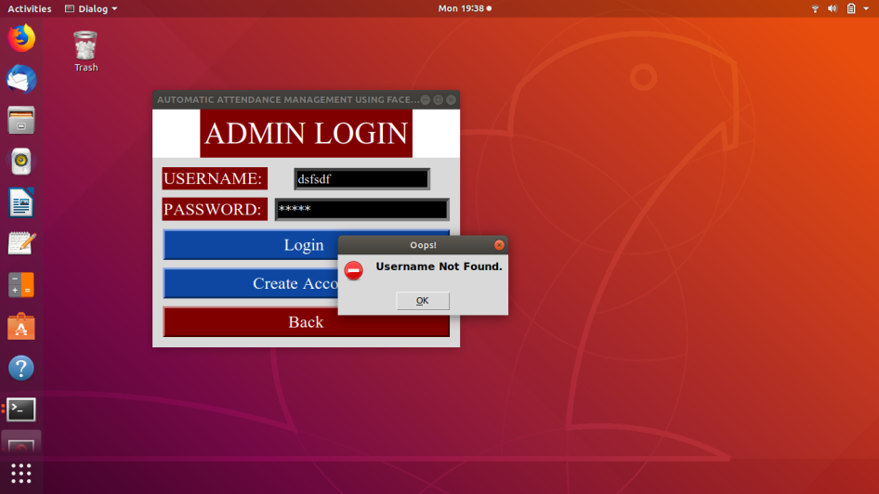

We shall create three more administrator accounts to show how the email containing attendance sheet is sent to all of them.

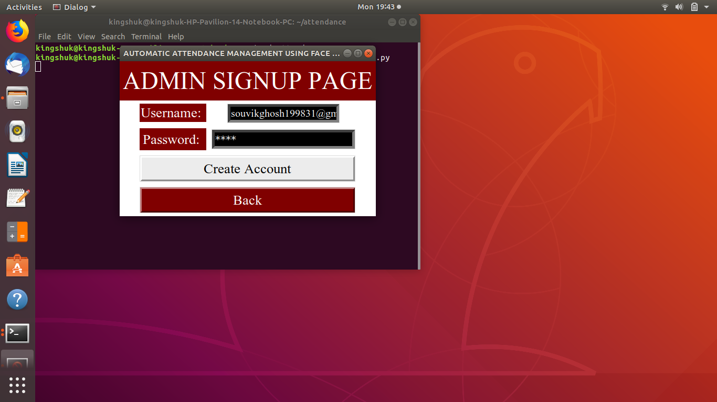

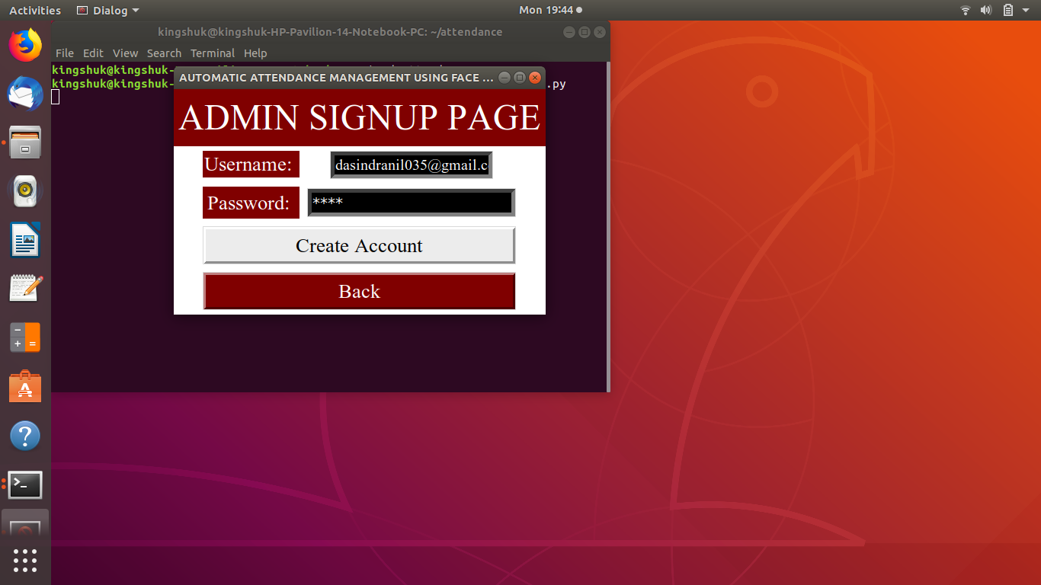

On successful admin login, the following screen opens with the following options:

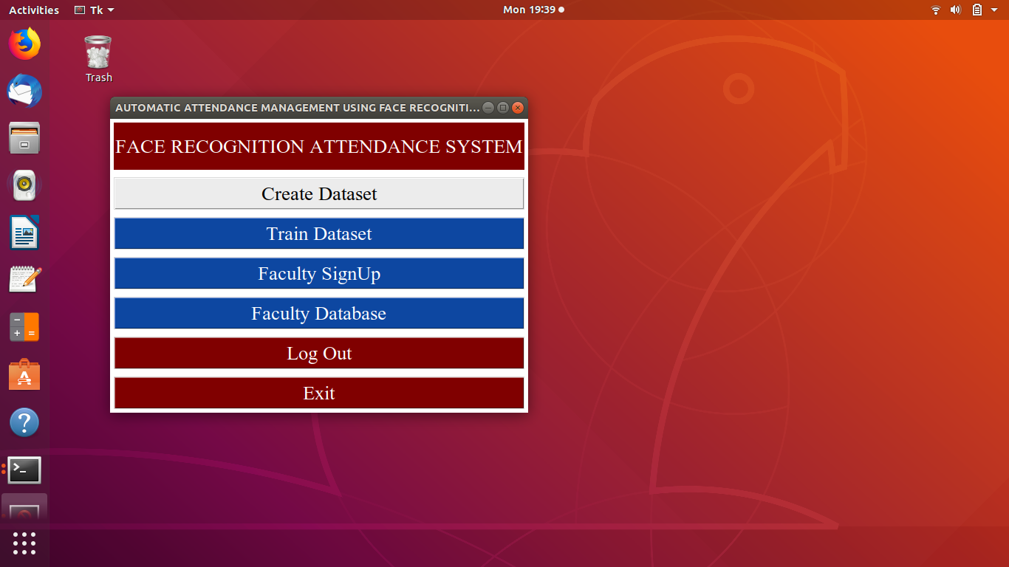

On clicking ‘Create Dataset’, the program will play a voice message to the user requesting them to keep their face in front of the camera and enter their ID. ID can be any unique identification string used in the college to refer to the respective student.

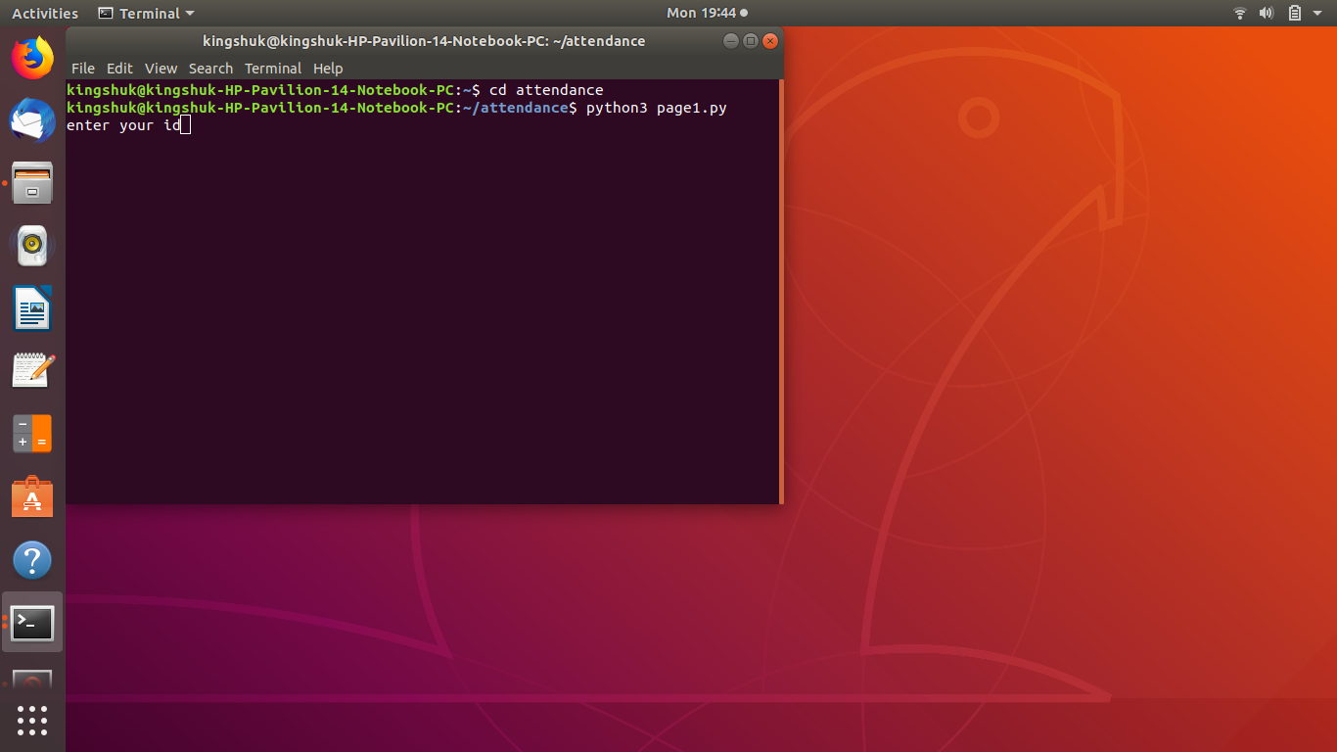

On entering ID, the program for capturing the dataset starts running. The output is shown below.

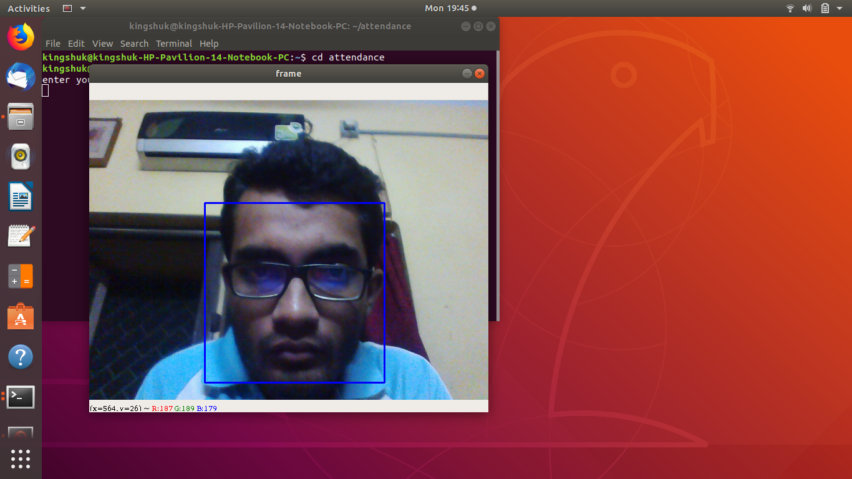

The program will successively capture 30 images of a single face and then close the camera. The captured images are converted into 64x64 pixel grayscale images and stored on the ‘dataset’ folder.

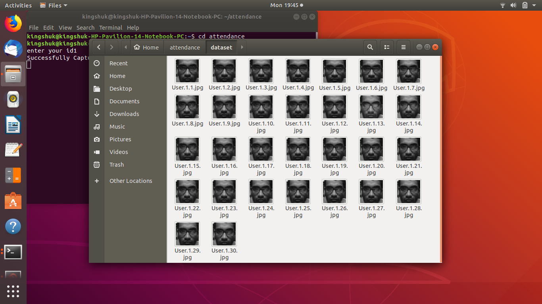

On clicking ‘Train Dataset’, the program will display a success message, as follows.

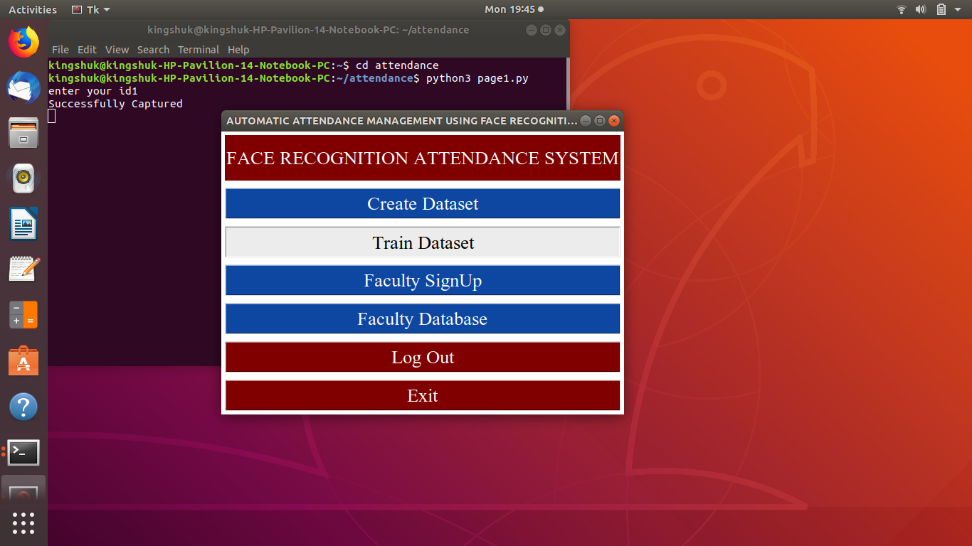

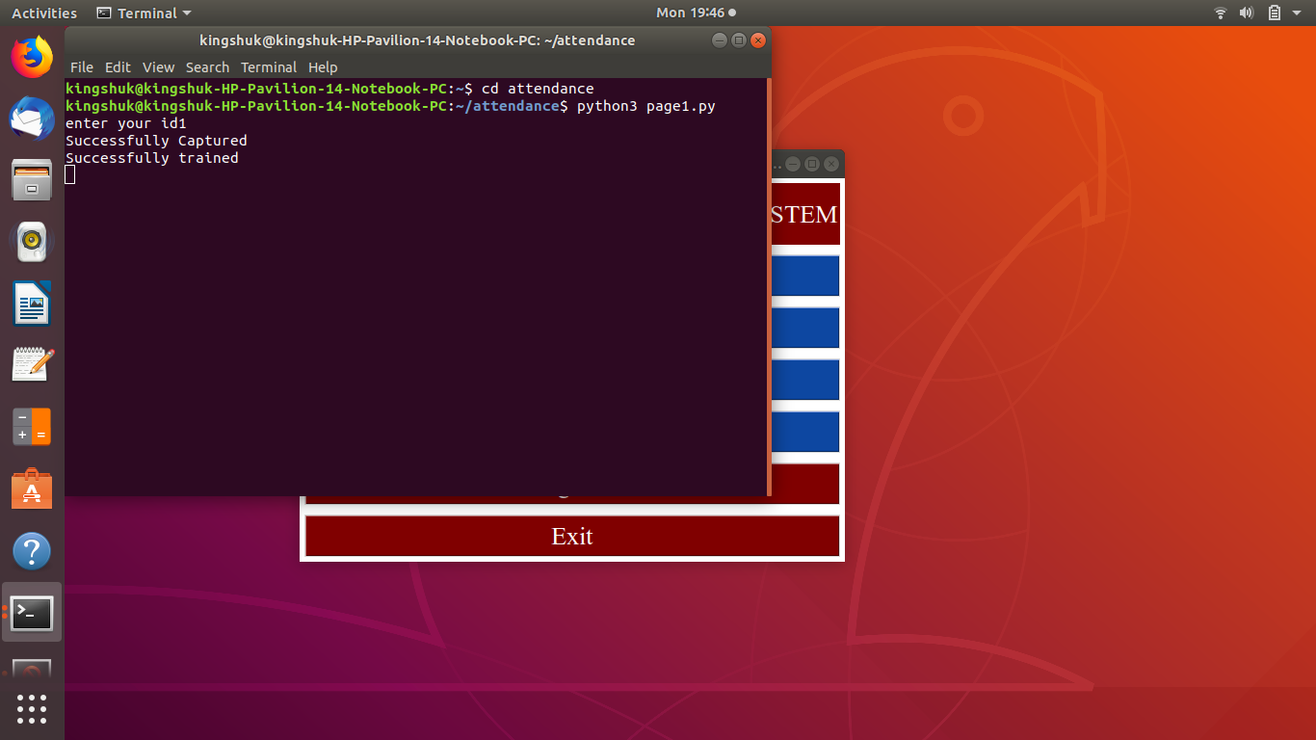

The faculty signup is also handled by the administrator. It takes place in the course of the following screenshots.

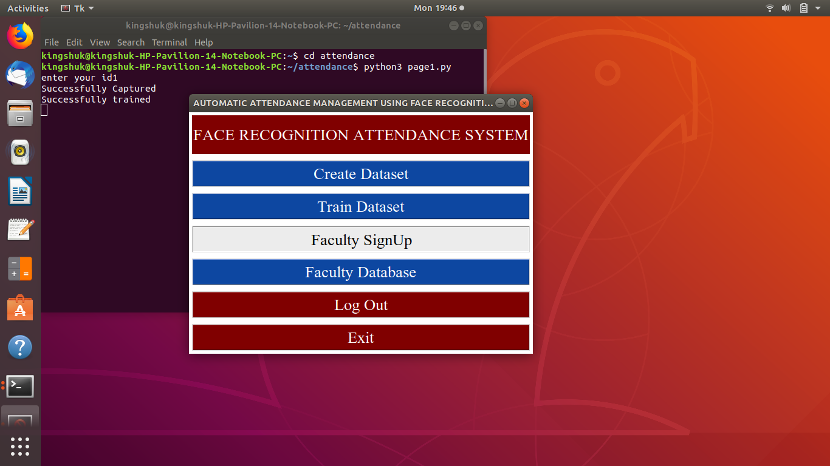

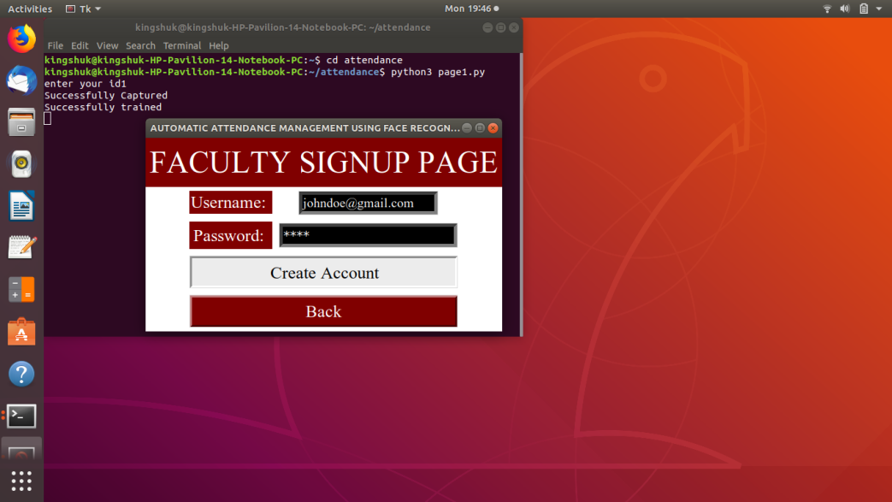

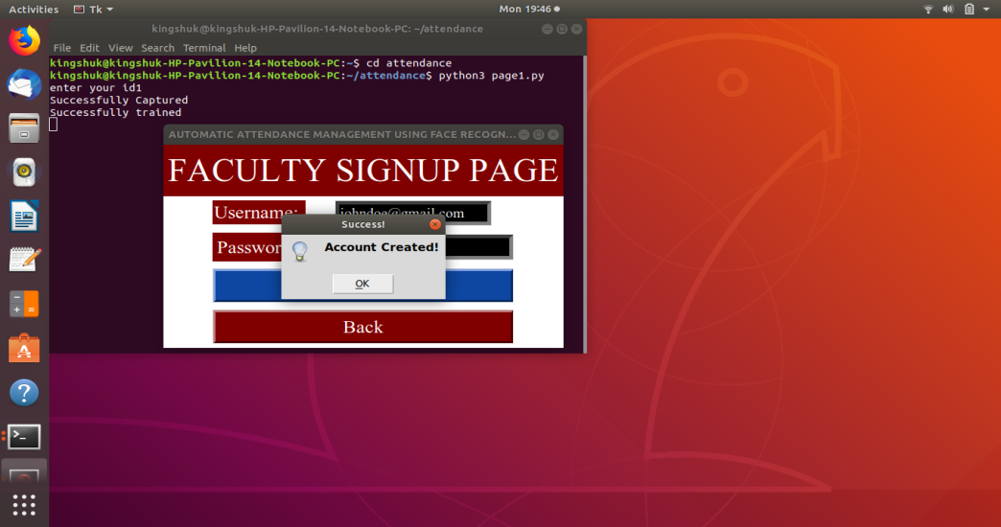

On clicking ‘Faculty Database’, the SQL Database will be invoked which will show the faculty record.

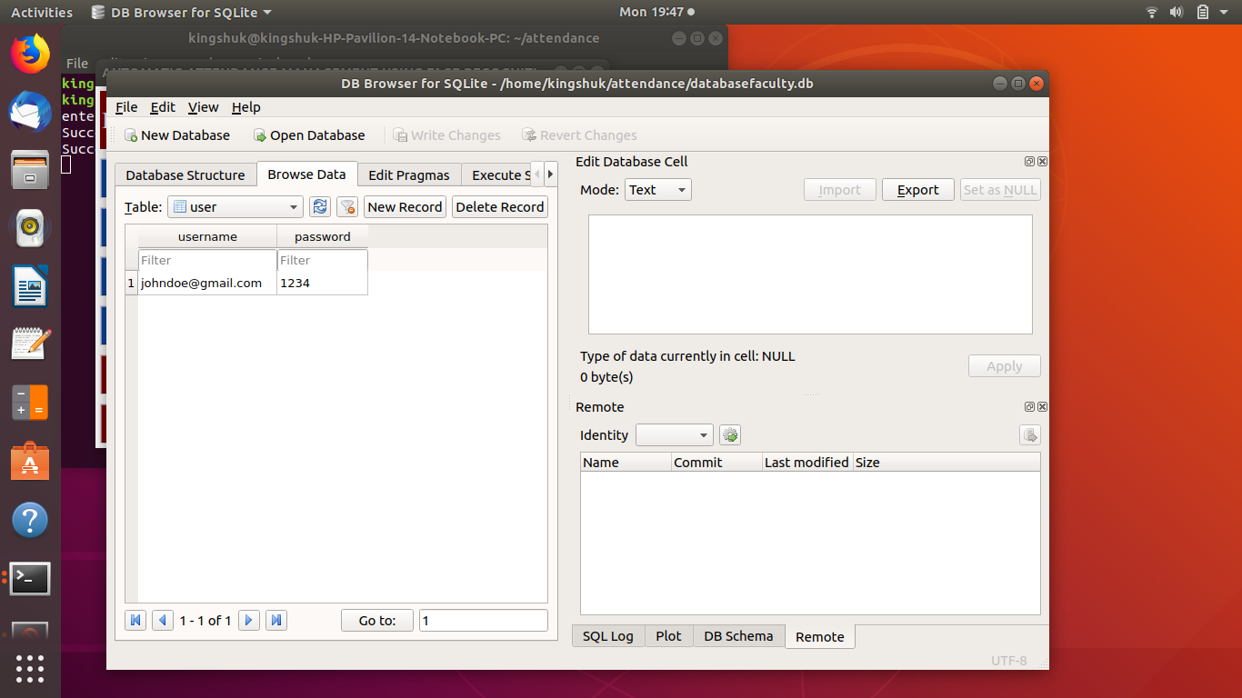

**5.1.2 Faculty Block**

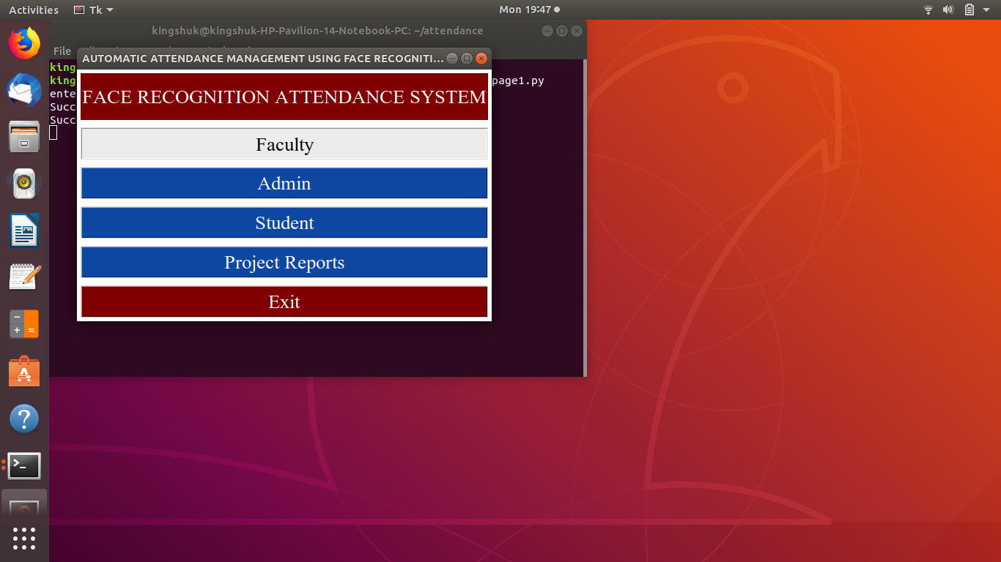

From first page, when we click faculty (after successful signing up of faculty under the supervision of the administrator), the following windows become available. The faculty login is handled as shown below.

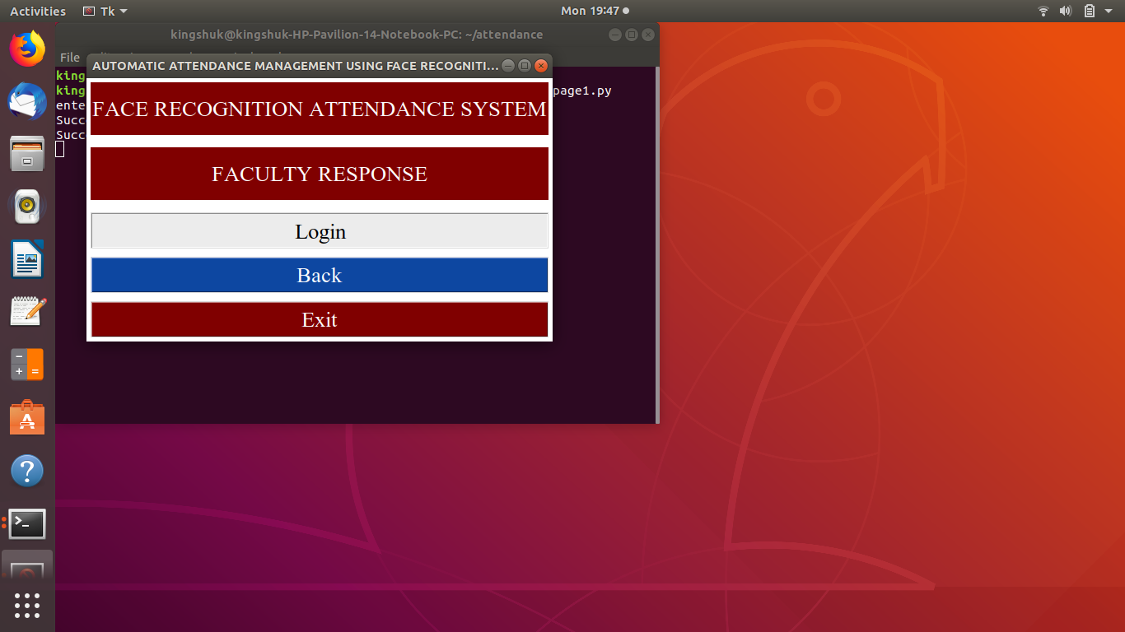

On successful login, the following page opens:

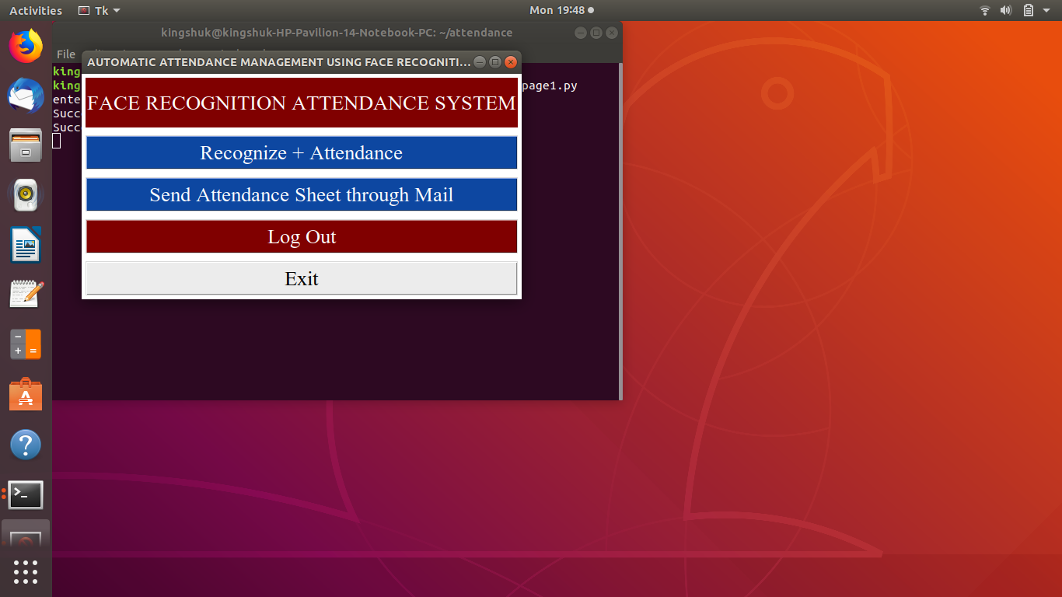

On clicking ‘Recognize+Attendance’, the camera opens and the program attempts to recognize the face, as follows.

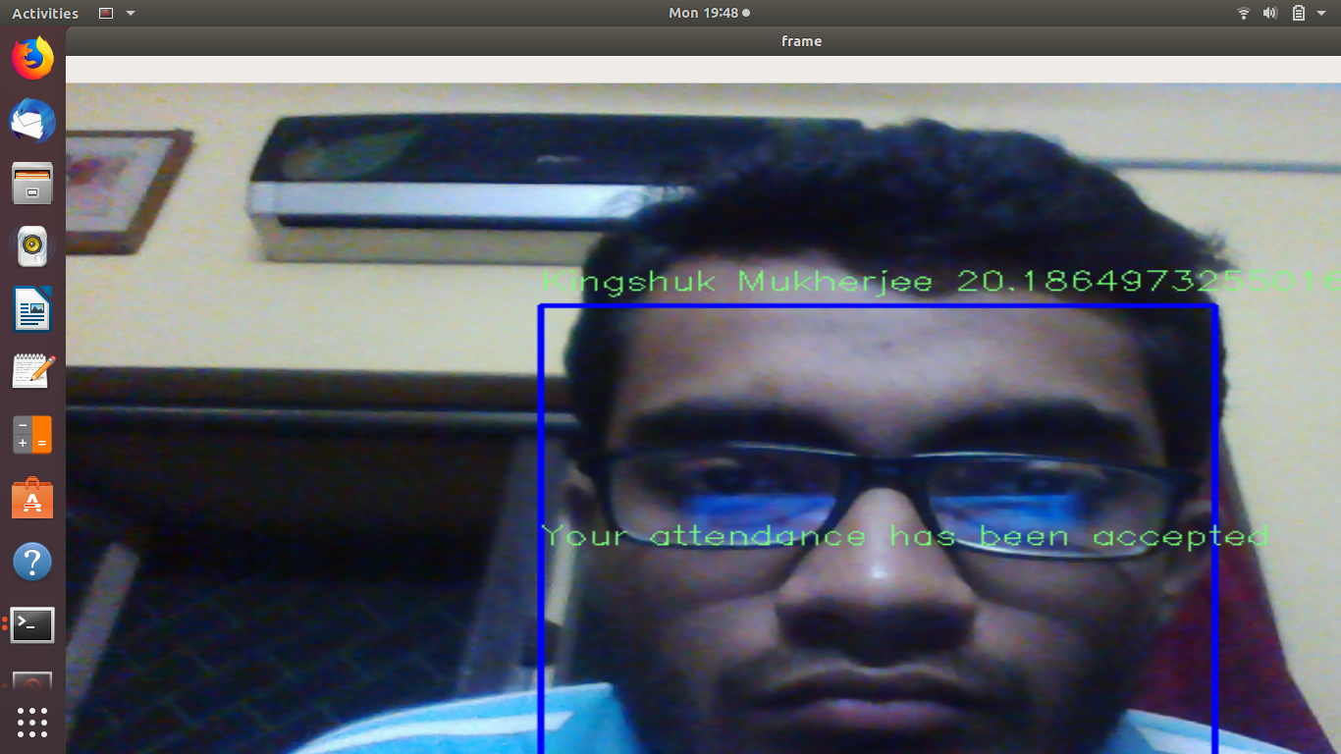

The program can also detect ‘spoofing’, i.e., providing an image of the student instead of real face, as shown below.

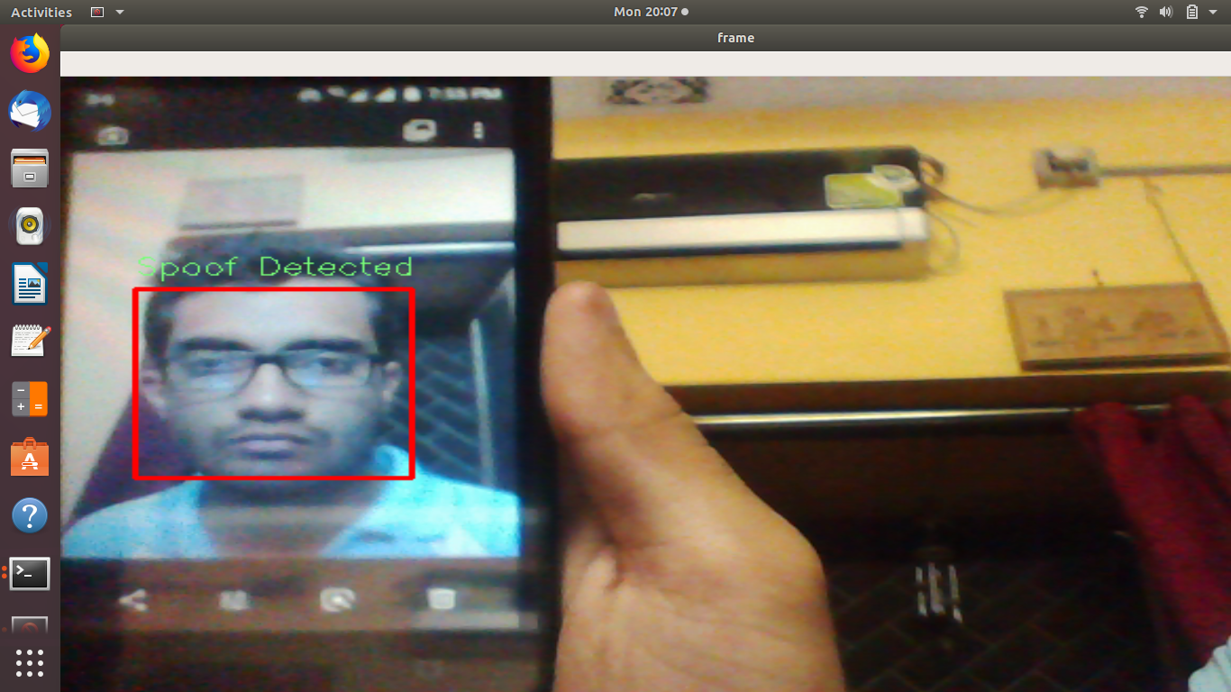

The generated attendance sheet is as follows:

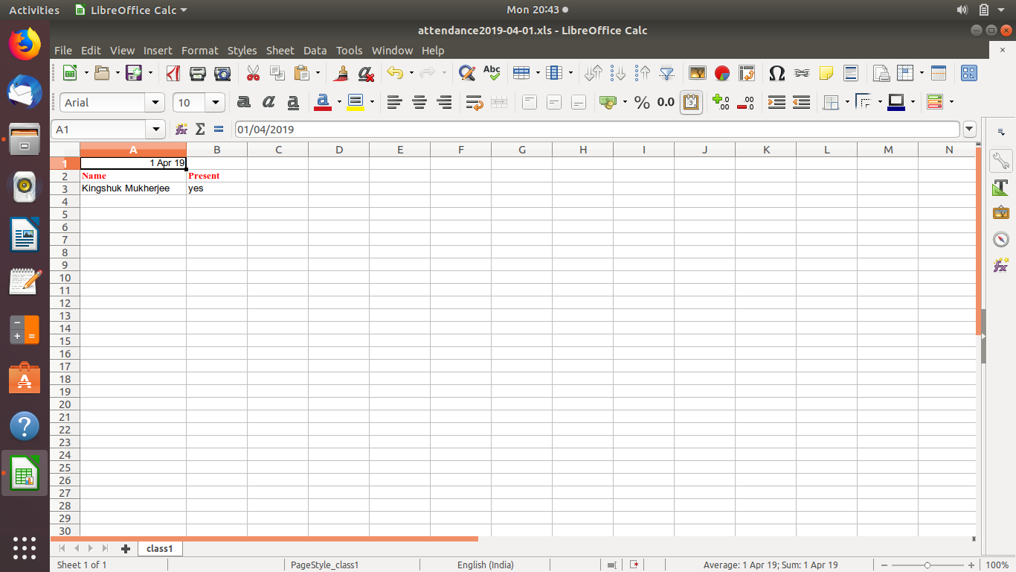

This sheet can be mailed to the other administrators by clicking ‘Send Attendance Sheet through Mail’ button.

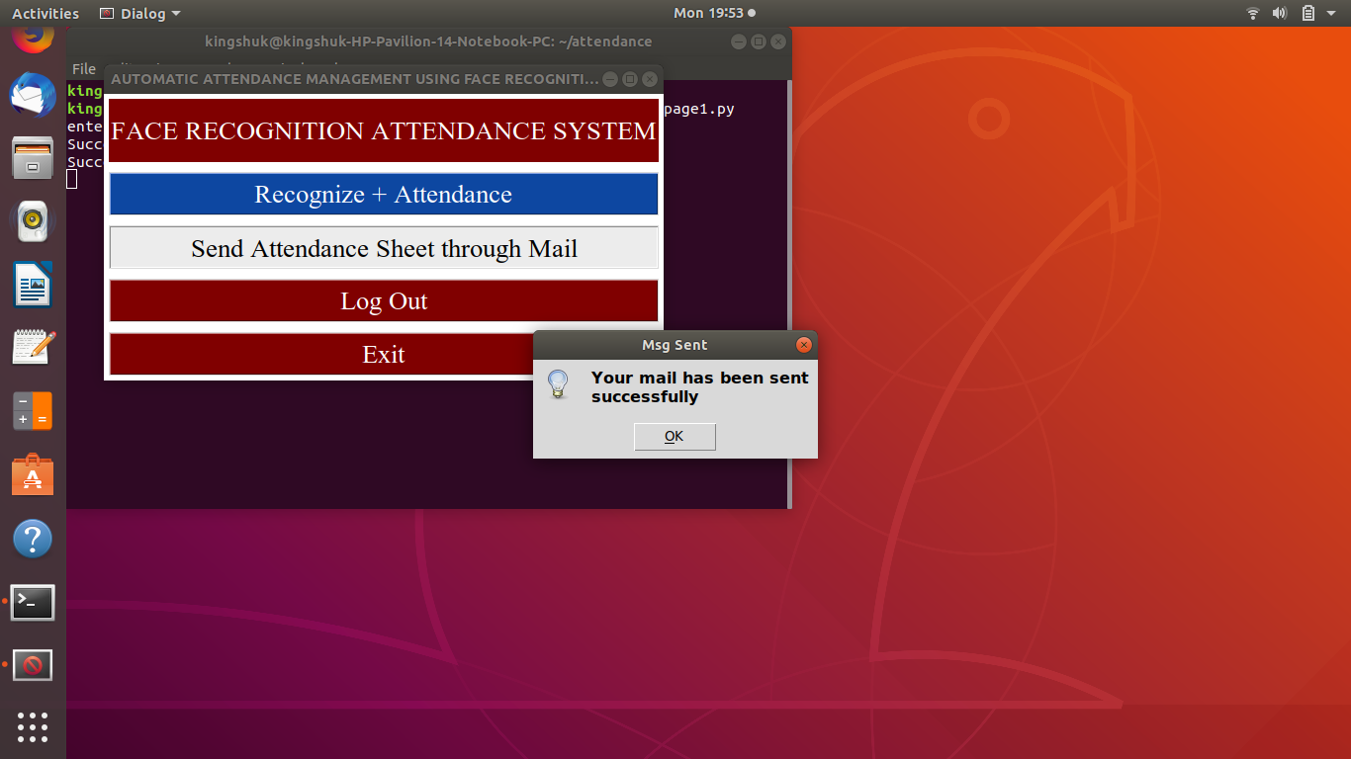

The emails are received on three different administrator accounts that were created eralier, as shown below.

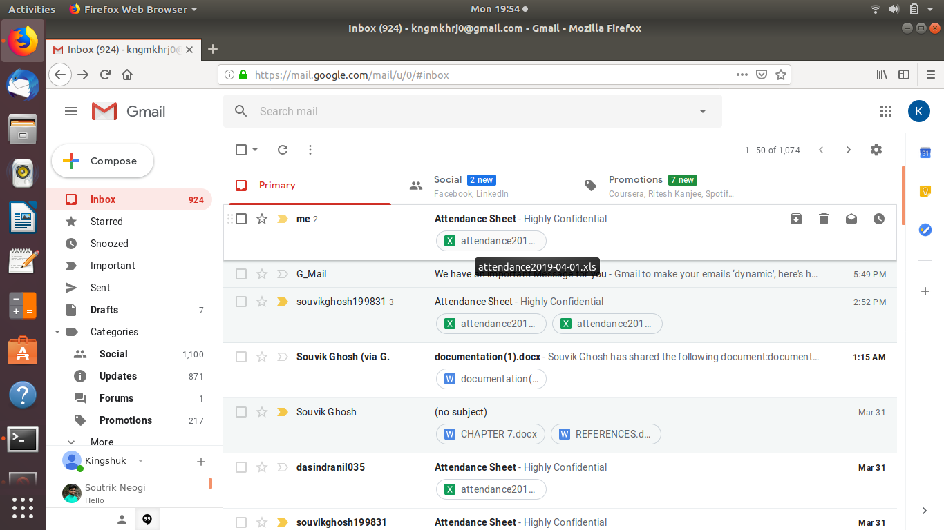

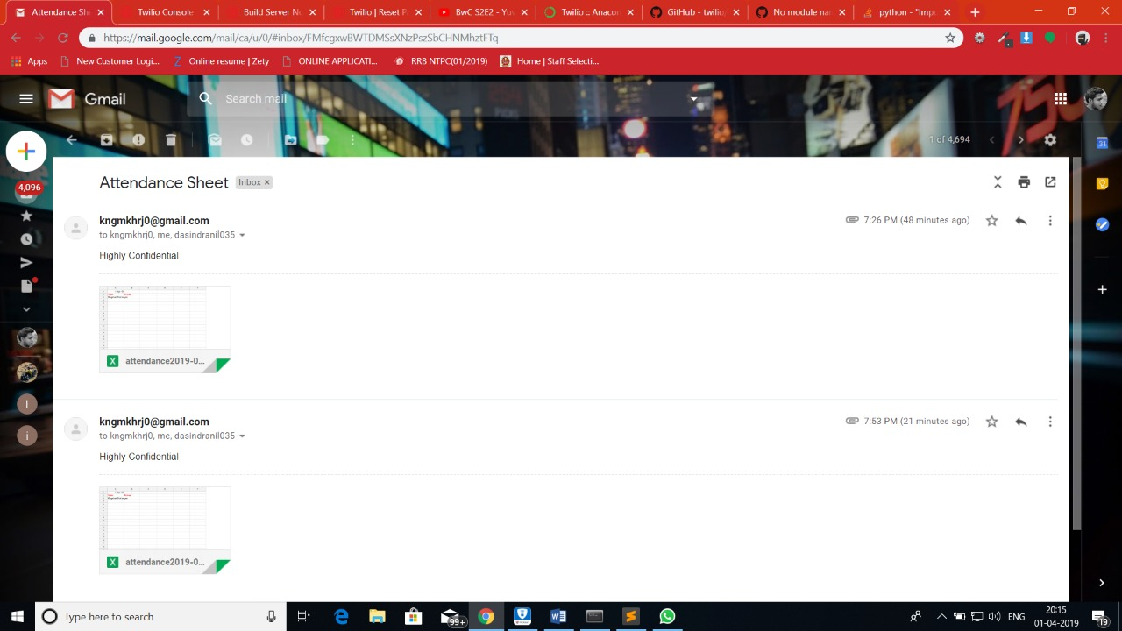

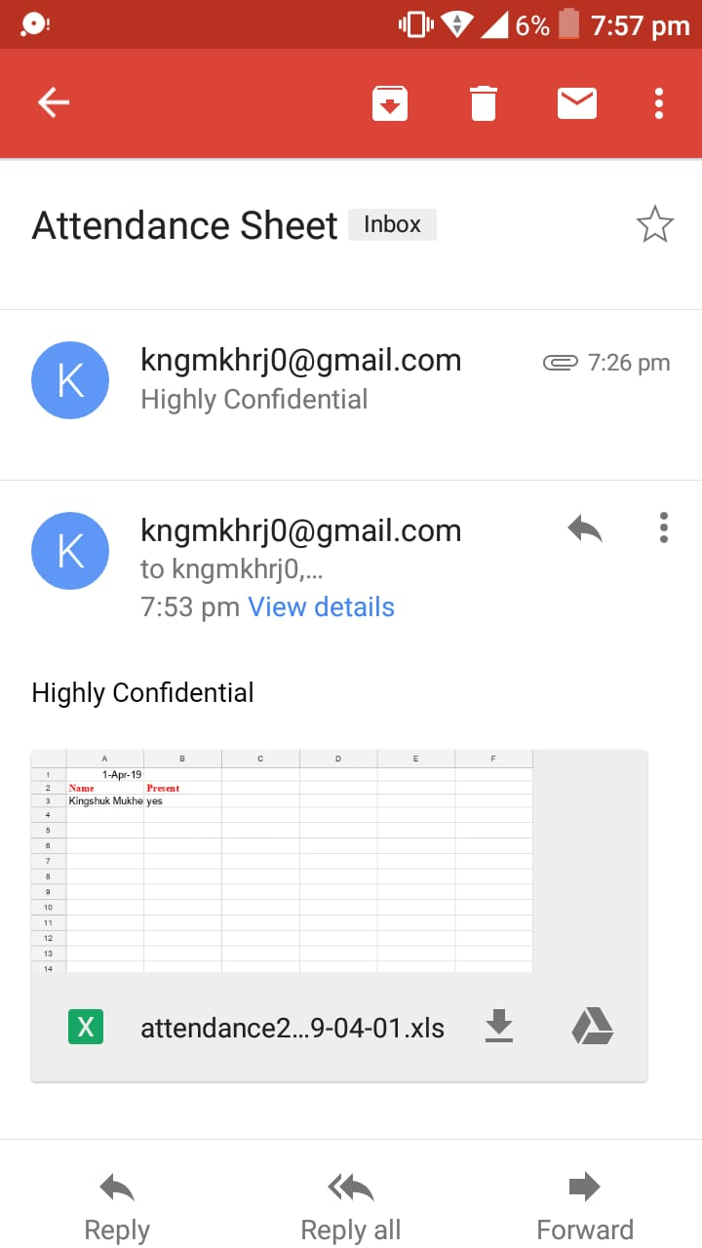

A student can check his attendance if he/she enters his ID in the following fashion.

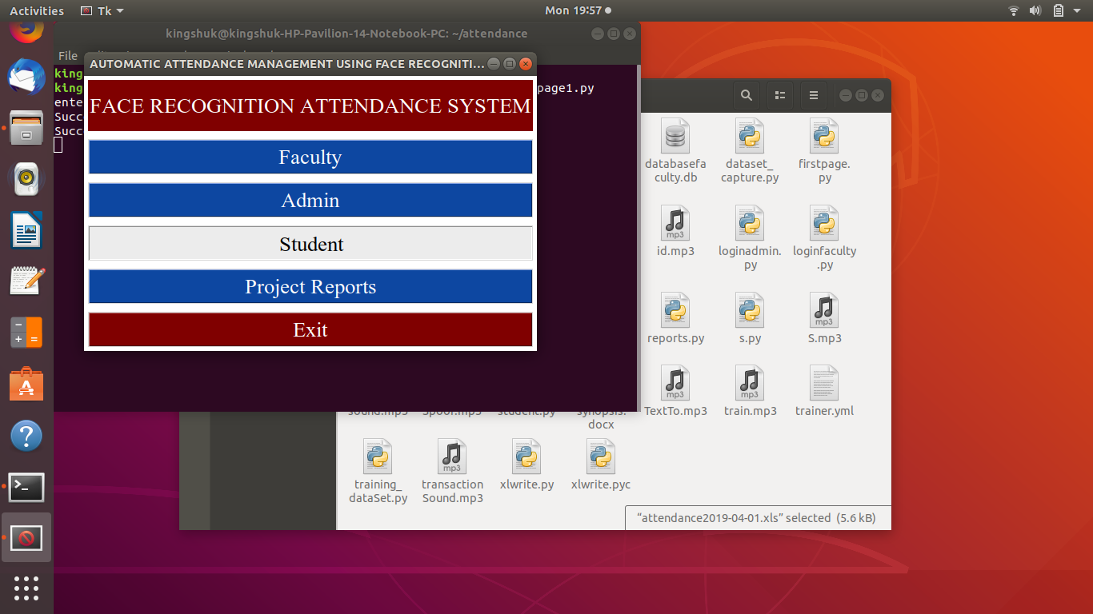

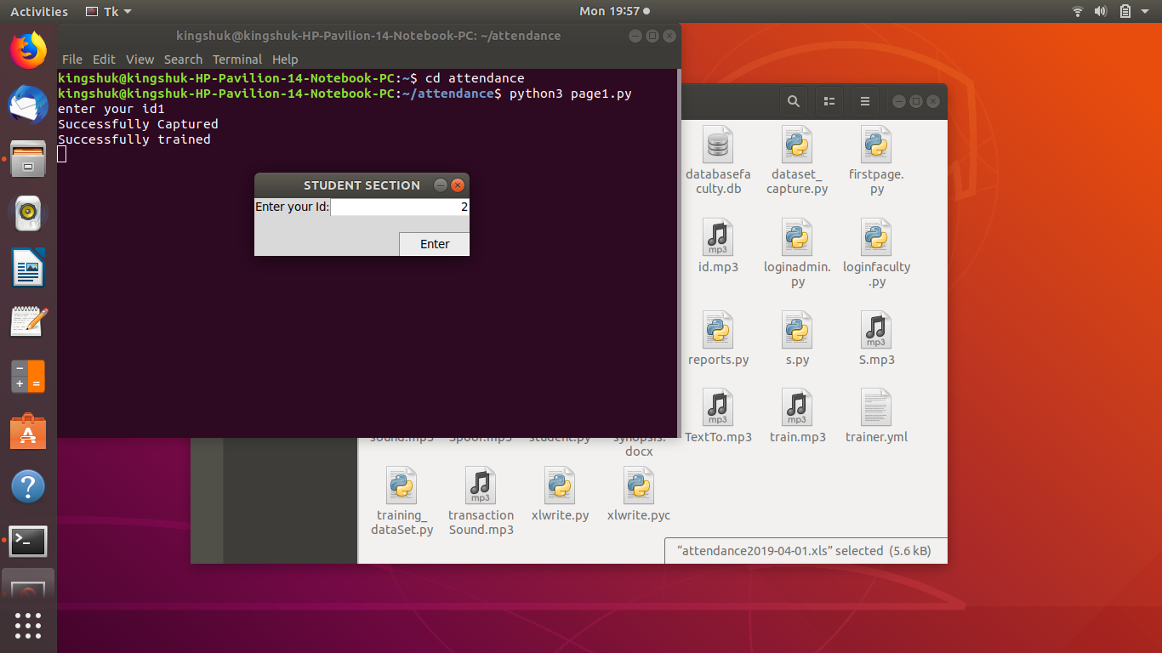

On clicking ‘View Attendance’, the same excel spreadsheet opens up.

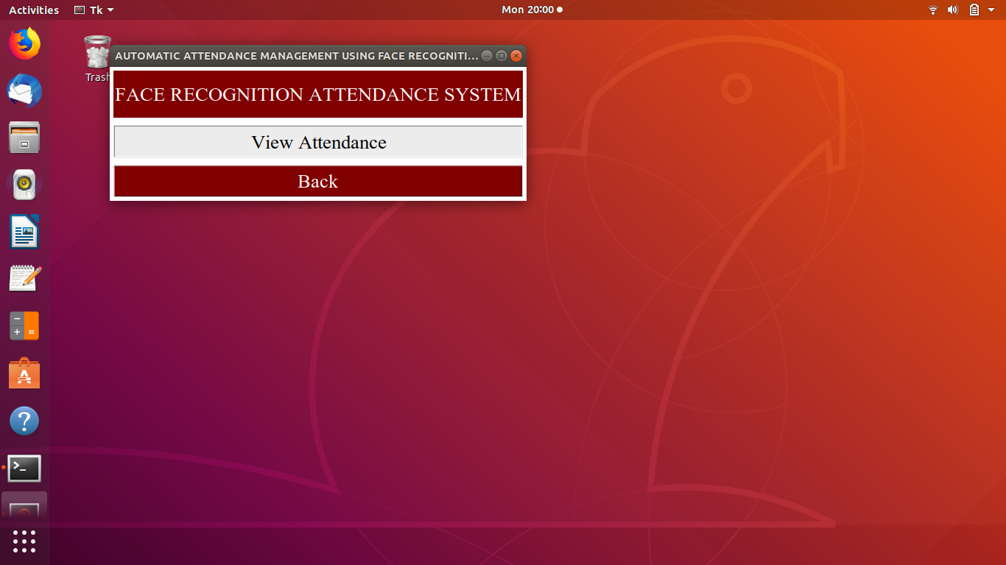

# 5.2 Discussions

The program was run on a variety of lighting conditions. It was observed that the capture rate was unsatisfactory when the face was not clearly distinguishable from the background and the lighting conditions were low. On running the program under suitable lighting conditions, it was observed that the confidence level was satisfactorily low (low confidence parameter being a positive point for the LBPH algorithm) and the faces were recognized successfully. Spoof detection was also conducted successfully as demonstrated above.

It is felt that the program has room for improvement in that it faces difficulty catering to low-light conditions successfully.

CHAPTER 6:

CONCLUSIONS

Before the development of this project. There are many loopholes in the process of taking attendance using the old method which caused many troubles to most of the institutions. Therefore, the facial recognition feature embedded in the attendance monitoring system can not only ensure attendance to be taken accurately and also eliminated the flaws in the previous system. By using technology to conquer the defects cannot merely save resources but also reduces human intervention in the whole process by handling all the complicated task to the machine. This method saves time and effort especially if there are large number of pupils in an organization. The only cost to this solution is to have sufficient space in to store all the faces into the database storage. Fortunately, there is such existence of micro SD that can compensate with the volume of the data. In this project, the face database is successfully built. Apart from that, the face recognizing system is also working well. A Graphical User Interface is also successfully built with fully functioning feature which is user-friendly. The database built is hidden from the user, however they can still access and make changes to it through the developed webpage with excellent interface. At the end, the system not only resolve troubles that exist in the old model but also provide convenience to the user to access the information collected which perfected the existence of technology to assist human’s needs.

# 5.2 Limitations of the System

1. The system cannot detect multiple faces at a time, i.e, students need to take turn one by one to get their attendance done.
2. The system can detect only frontal face. It cannot detect any side faces or face kept at any different angles.
3. Image quality affects how well facial-recognition algorithms work. The image quality of scanning video is quite low compared with that of a digital camera. Even high-definition video is, at best, 1080p (progressive scan); usually, it is 720p. These values are equivalent to about 2MP and 0.9MP, respectively, while an inexpensive digital camera attains 15MP. The difference is quite noticeable.
4. When a face-detection algorithm finds a face in an image or in a still from a video capture, the relative size of that face compared with the enrolled image size affects how well the face will be recognized. An already small image size, coupled with a target distant from the camera, means that the detected face is only 100 to 200 pixels on a side. Further, having to scan an image for varying face sizes is a processor-intensive activity. Most algorithms allow specification of a face-size range to help eliminate false positives on detection and speed up image processing.
5. The relative angle of the target’s face influences the recognition score profoundly. When a face is enrolled in the recognition software, usually multiple angles are used (profile, frontal and 45-degree are common). Anything less than a frontal view affects the algorithm’s capability to generate a template for the face. The more direct the image (both enrolled and probe image) and the higher its resolution, the higher the score of any resulting matches.
6. The distance of the face from the camera also matters. The face should be kept at a reasonable distance from the camera otherwise the image quality will not be prominent and as a result the recognition process might not work well.
7. Even though high-definition video is quite low in resolution when compared with digital camera images, it still occupies significant amounts of disk space. Processing every frame of video is an enormous undertaking, so usually only a fraction (10 percent to 25 percent) is actually run through a recognition system. To minimize total processing time, agencies can use clusters of computers. However, adding computers involves considerable data transfer over a network, which can be bound by input-output restrictions, further limiting processing speed.

# 5.2 Future Scope

The system that we have developed successfully, has the ability to accomplish the task of marking the attendance in the classroom automatically and output is obtained in an excel sheet as desired in real time. However, in order to develop a dedicated system which can be implemented in an educational institution or in offices, a very efficient algorithm which is insensitive to the lighting conditions has to be developed. Also, a camera of the optimum resolution has to be utilized in the system. Another important aspect where we can work is creating an online database of the attendance and automatic updating of the attendance into it keeping in mind the growing popularity of Internet of Things. This can be done by creating a standalone module which can be installed in the organization, having access to internet, preferably a wireless system. Another modification is to apart from sending mails which require internet connectivity, we can also send messages to the pupils regarding their attendance. This can be done using Twilio. This system can also be implemented in an application (Android and iOS) for better flexibility. This system can also be designed to check for all the intruders who are not present in the system’s database using a CCTV camera. These developments can greatly improve the developments of the project.

REFERENCES

1. Fadelelmoula, Tarig. (2018). Impact of class attendance on student performance. International Research Journal of Medicine and Medical Sciences. 10.30918/IRJMMS.62.18.021.
2. Viola and Jones, "Rapid object detection using a boosted cascade of simple features", Computer cool Vision and Pattern Recognition, 2001
3. Papageorgiou, Oren and Poggio, "A general framework for object detection", International Conference on Computer Vision, 1998.
4. https://towardsdatascience.com/face-recognition-how-lbph-works-90ec258c3d6b
5. http://www.scholarpedia.org/article/Local_Binary_Patterns